Quilt Index | Black Diaspora Quilt History Project presents

Black Quilts
Curriculum Guide inspired by Black quilters, their quilts, history, & praxis
guide designed by liv furman, phd

This guide includes: quilt terms, diasporic quilts, quilt scholarship

Cuesta Benberry (left) & Coat of Many Colors Quilt. c. 1980. Gees Bend, AL.
image courtesy of Michigan State University Museum

for more info visit quiltindex.org

(cover page)

About the BDQHP

The Quilt Index Black Diaspora Quilt History Project (BDQHP) is a National Endowment for the Humanities funded initiative. The BDQHP is an intentional effort towards preserving and making accessible, in the Quilt Index, primary and secondary sources on African American, African, and African Diasporic quilt history drawn from geographically-dispersed public and private collections. The BDQHP is a two-year project running from 2022 through 2024. The scope of the project will entail Quilt Index staff working with a diverse group of stakeholders to create digital humanities resources on African American, African, and African Diaspora quilt history. Resources emerging from this project will make known and honor the cultural legacy of Black quilters throughout the diaspora.

Black Diaspora Quilt History Project Website: https://quiltindex.org/view/?type=docprojects&kid=62-185-1

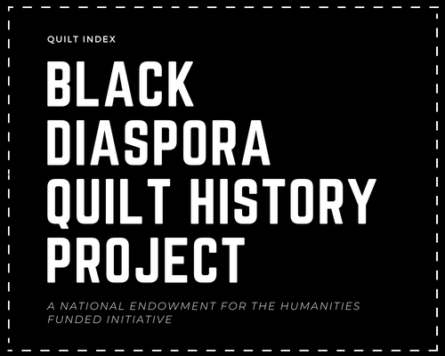

(pg.i)

About the BDQHP Curriculum Guide

The Black Diaspora Quilt History Project Curriculum Guide is an extension of the Quilt Index Black Diaspora Quilt History Project (BDQHP). The Black Diaspora Quilt History Curriculum Guide is designed to make known and honor the cultural legacy of Black quilters throughout the diaspora. This guide is designed for educators, quilters, organizers, and other individuals who seek educational materials to expand their knowledge about Black quilters, their quilts, and quilt related ephemera.

(pg.ii)

Table of Contents

Quilt Terms: basic terms related to quilting

Black Quilts: curated collection of quilts from the Quilt Index made by Black quilters throughout the diaspora

Quilt Artists: info about 5 prominent quilt artists,

More Quilt Artists: a list of Black quilters and quilt guilds/groups

Quilt Communities: an extended list of Black quilt guilds/groups

Quilt Scholarship: lists of quilt related books, articles, blogs, exhibitions, videos, conferences, podcasts, etc.

Reflecting Forward: reflection questions and prompts for deeper engagement

pg. 1

pg.8

pg.33

pg.44

pg.47

pg.51

pg.67

(pg.iii)

Quilt Index

Quilt Terms

Additional quilt terms and techniques are listed in the Quilt Index Documenting Quilts Guide, linked below.

https://kora.quiltindex.org/files/51-150-1/Quilt_Index_Guide_To_Documenting_Quilts.pdf

(pg. 1)

Quilt Terms

The vocabulary terms and definitions are not intended to be fixed or comprehensive. Rather, they are a starting place for the explorations in this curriculum guide.

Quilt: a textile, or bed covering, typically composed of 2 or more layers of fabric or fiber. Often consists of the following 3 layers: quilt top, batting/wadding, & quilt back.
Quilting, as a verb, is often used to describe the act of sewing the layers of fiber together.

Quilt Top: top-most layer of a quilt, usually the most intricate/decorated part of the quilt

Quilt Back: bottom side/layer of the quilt

Batting/Filling/Wadding: layer of fiber material layered between the quilt top and quilt back. This layer provides insulation and thickness for the quilt.

(pg. 2)

Quilt Index

Quilt Terms contd.

Applique Quilting: quilting technique where smaller pieces of fabric are sewn onto a larger foundation fabric.

Pieced Quilting: quilting technique where pieces of fabric are assembled and/or stitched together side by side, this method is especially effective with geometric patterns

Quilt Square or Quilt Block: a unit designed to construct a quilt. A quilt square/block can be made of one singular piece of fabric or be composed of multiple smaller pieces that are sewn together. Often, if quilt squares/blocks are used in a quilt, there are multiple squares/blocks sewn together to create the quilt.

This image features 2 hand-appliqued quilt squares from a sampler quilt.

Quilted by Cuesta Benberry, Annette Ammen, Lois Mueller and the Kinloch Community Center Ladies

Quilts (above & below) Collection of the Michigan State University Museum
Below is a hand-pieced quilt top with 9 quilt squares, quilted by Mary Atkins.
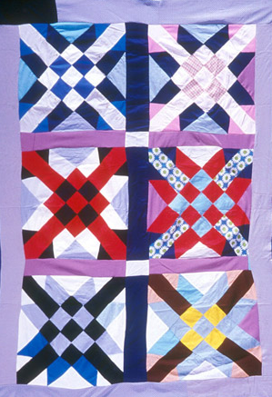
(pg. 3)

Quilt Index

Quilt Terms contd.

Flower Basket, by Effie Hayes. 1988. Detroit, MI.

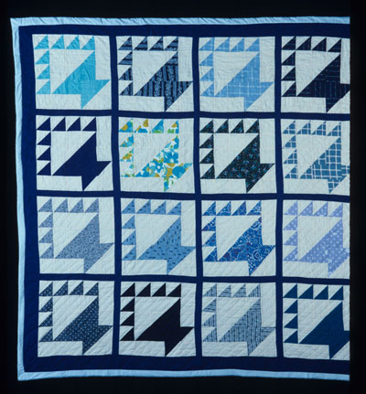
Above is a pieced quilt with 16 quilt squares, quilted by Effie Hayes. The border and sashing of the quilt are the same dark blue color. A light blue cotton binding is along the outer edge.

sashing: strips of fabric sewn around or between squares/blocks in a quilt

borders: strips of fabric that frame the exterior edges of the quilt design. Some quilts have more than one border.

binding: strips of fabric used to seal, or complete, the edges of the quilt

(pg. 4)

Quilt Sample
Pieced Quilt

Some quilt patterns are known by multiple names. Some names used to identify the pattern used in this quilt top include: Bear's Foot, Bear's Paw, Duck's Foot in the Mud, Hand of Friendship, Tea Leaf Design, The Best Friend, Cat's Paw, Batsche, Small Hand, and Illinois Turkey Track.
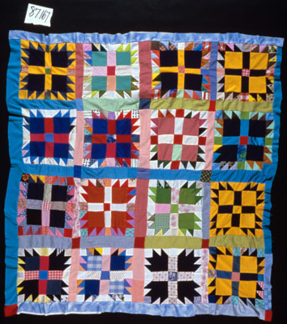

Count the number of blocks in the quilt top. How many quilt blocks are in this quilt top?

Crow Foot in the Mud, by Sina R. Phillips. 1983. Muskegon, MI.
Collection of the Michigan State University Museum

This quilt top has sashing of various colors between each quilt block. The border is also composed of various colors.

(pg. 5)

Quilt Sample
Applique Quilt

...And a Time to Dance, by Myrah Brown Green. 2003. Brooklyn, New York.
Collection of the Michigan State University Museum
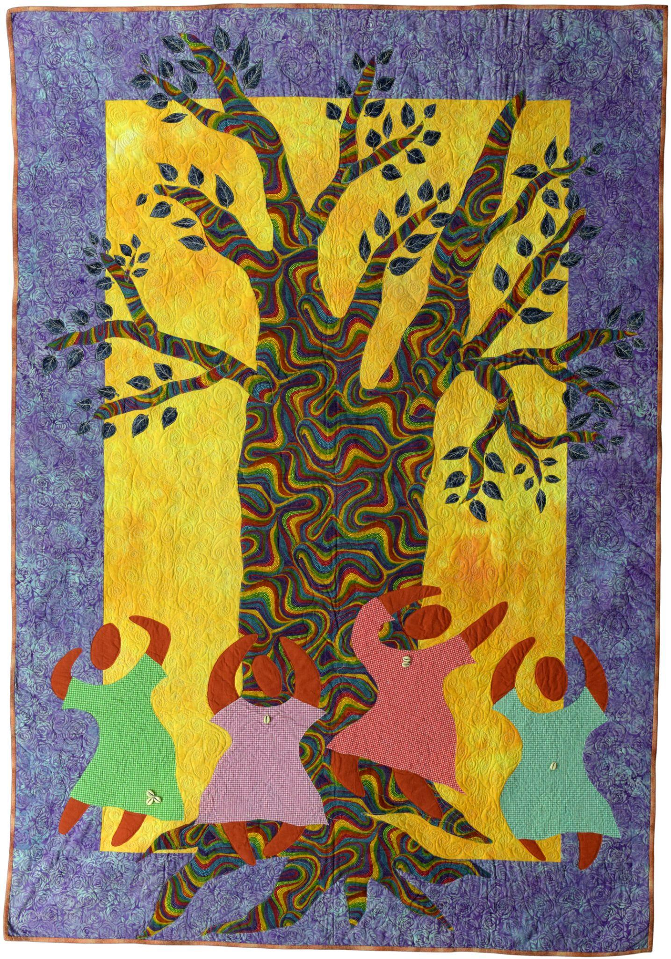

What details do you notice about this quilt?

What topic do you think this quilt explores?

This quilt has a 8 1/8 inch purple and blue floral print border & a thin tan binding on the outer edge.

(pg. 6)

Quilt Terms: Quilt Samples
Links to quilts from this section.
More info about each quilt is listed on the Quilt Index Website.

...And a Time to Dance, by Myrah Brown Green.
2003. Brooklyn, New York.
https://quiltindex.org//view/?type=fullrec&kid=12-8-6782

Afro-American Women and Quilts, by Cuesta Benberry, Annette Ammen, Lois Mueller and the Kinloch Community Center Ladies
1979. St. Louis, MO.
https://quiltindex.org//view/?type=fullrec&kid=12-8-5240

Crow Foot in the Mud, by Sina R. Phillips.
1983. Muskegon, MI.
https://quiltindex.org//view/?type=fullrec&kid=12-8-6164

Flower Basket, by Effie Hayes.
1988. Detroit, MI.
https://quiltindex.org//view/?type=fullrec&kid=12-8-852

Nine Square, by Mary Atkins
c1980. Kalamazoo, MI.
https://quiltindex.org//view/?type=fullrec&kid=12-8-78

(pg. 7)

Quilts by Black Quilt Makers

Curated collection of quilts by Black quiltmakers throughout the diaspora, with prompts for close readings, self-reflection, and artmaking.

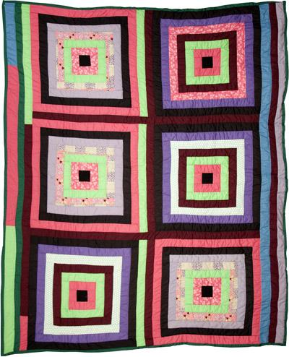
Housetop, by China Pettway. Gee's Bend, Alabama. 2009.
Collection of the Michigan State University Museum

(pg. 8)

Quilt 1

Afro-American Women and Quilts,
by Cuesta Benberry, Annette Ammen, Lois Mueller and the Kinloch Community Center Ladies. St. Louis, Missouri. 1979

Collection of the Michigan State University Museum

More info about this quilt on the Quilt Index Website: https://quiltindex.org//view/?type=fullrec&kid=12-8-5240

(pg. 9)

Afro-American Women and Quilts,
by Cuesta Benberry, Annette Ammen, Lois Mueller and the Kinloch Community Center Ladies. St. Louis, Missouri. 1979

"Afro-American Women and Quilts is the only quilt that Cuesta Benberry made. In every block of this sampler quilt, Cuesta uses a visual symbol to pay tribute to quilts made by different African-American quiltmakers."

Read the inspiration and meaning of each quilt square on the Quilt Index website. Try identifying each quilt square from the written descriptions. After reading, reflect on the following questions:
- What do you think is the purpose and/or utility of creating a sampler quilt to document and preserve this history?
- Is there a quilt square that you are drawn to the most? What do you like about this quilt square? What questions does this quilt square make you think about?

The following two quilt squares were inspired by quilts made by Cuesta Benberry's mother-in-law and grandmother-in-law. Check out these quilts in the Quilt Index collection.
- W.P.A. Tulip, by Minnie Benberry
- Lady's Shoe Quilt, by Fannie Cork

Quilt Inspired Activity:
If you were to make a quilt inspired by African American quiltmakers or other artists, what quilters or artists would inspire your quilt the most? What would your quilt look like? What patterns or quilt styles would you use?

(pg. 10)

Quilt 2

Zinnia, by Leona Johnson. Monrovia, Liberia. 1992

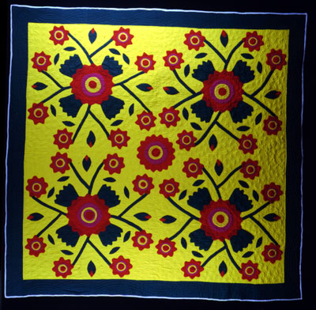

Collection of the Michigan State University Museum

More info about this quilt on the Quilt Index Website:
https://quiltindex.org//view/?type=fullrec&kid=12-8-399

(pg. 11)

Zinnia, by Leona Johnson. Monrovia, Liberia. 1992

Read the background information about this quilt on the Quilt Index website. After reading, reflect on the following questions:
- What are the main colors used in this quilt?
- What color is the quilt border?
- What color is the binding of this quilt?
- Is this quilt an appliqued quilt or a pieced quilt? What visuals help you to identify this information?

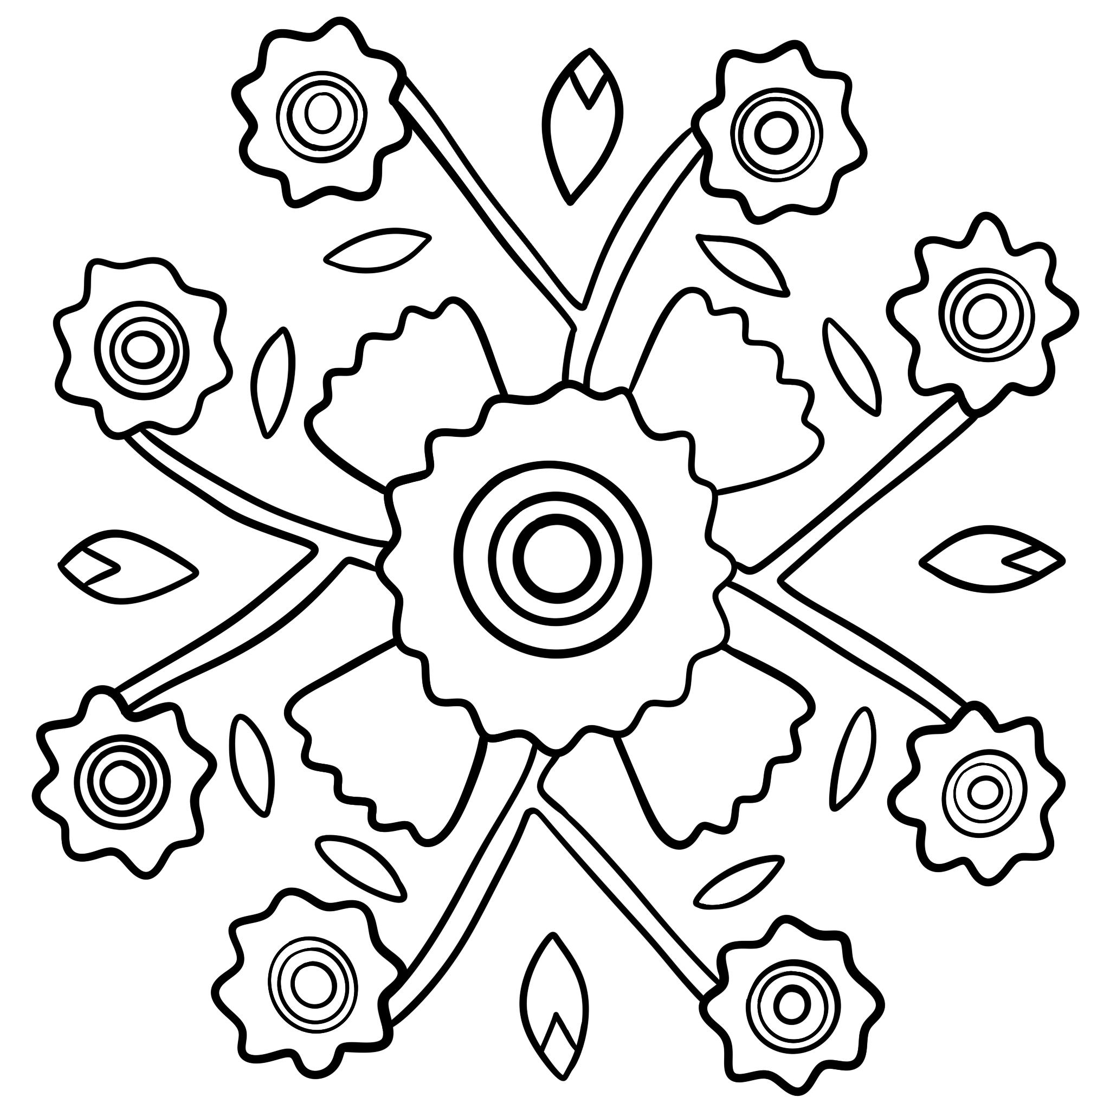

Quilt Inspired Activity:
This quilt contains a pattern that is repeated 4 times around a flower in the center of the quilt. Trace the pattern on a piece of paper. Then, using pieces of construction paper or other accessible materials (i.e. crayons, markers, recycled paper, etc.) to fill in the pattern. Try matching the colors in the original quilt first, then try creating your own variation of colors and flower arrangements.

(pg. 12)

Quilt Pattern Activity Template

Inspired by: Zinnia, by Leona Johnson. Monrovia, Liberia. 1992

(pg. 13)

Quilt 3

Tryin' to Grab a Piece of the Pie, by Carolyn Mazloomi. West Chester, OH. 1994
Collection of the Michigan State University Museum

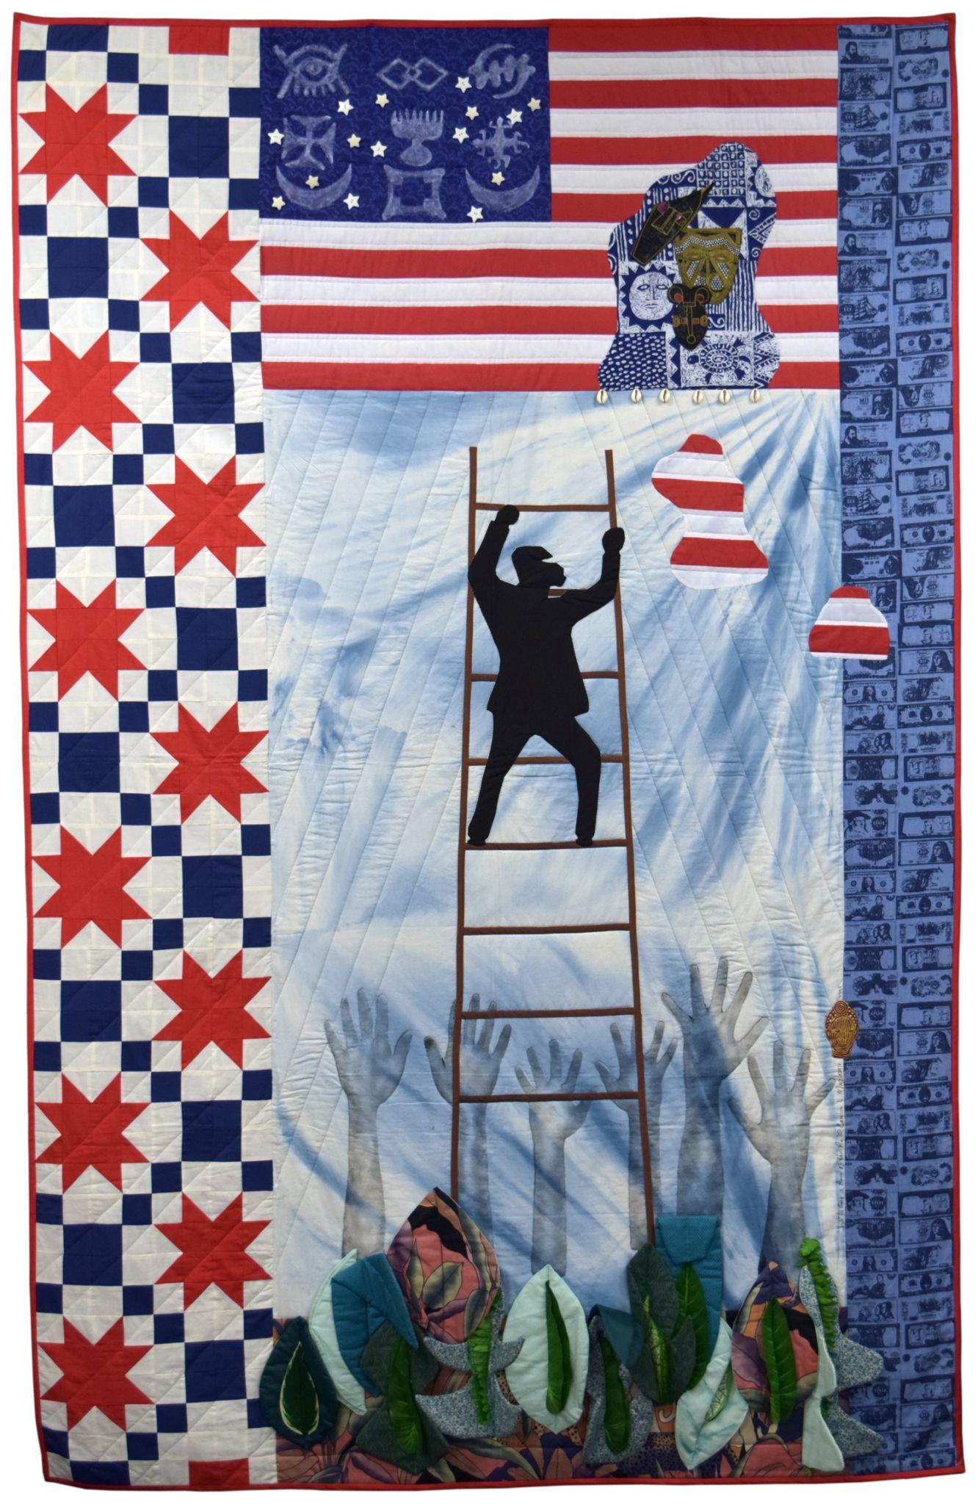

More info about this quilt on the Quilt Index Website
https://quiltindex.org//view/?type=fullrec&kid=8-5-484

(pg. 14)

Tryin' to Grab a Piece of the Pie,
Carolyn Mazloomi, West Chester, OH. 1994

Features or notes about this quilt's appearance, materials, or construction:
- A narrative pictorial quilt incorporating historical and political elements by facilitating a discussion about socioeconomic mobility and the African American quest for the American dream.

Read the background information about this quilt on the Quilt Index website. After reading, reflect on the following questions:
- What images, symbols, or visuals do you notice in this quilt? What do they make you think about?
- Consider the description of the quilt along with the title and visuals you have identified. Write a few sentences about the ways this quilt artist may have constructed the quilt to embody a narrative or meaning. In your writing, be sure to document details of the quilt using descriptive language. Discuss your ideas with a partner or small group.

Quilt Terms:
The quilt artist, Carolyn Maazloomi, utilizes repeating pieced quilt squares on the left side of the quilt. The red and white pattern is often called a sawtooth star quilt pattern. The blue and white quilt square is a variation of what is often called a nine patch quilt pattern. Other names for the blue and white quilt square pattern include: plain block, sheepfold, or puss in the corner.

(pg. 15)

Quilt 4

Portraits of South African Black Women of the Anti-Apartheid Struggle, by Fina Nkosi. Soweto, South Africa. 2004

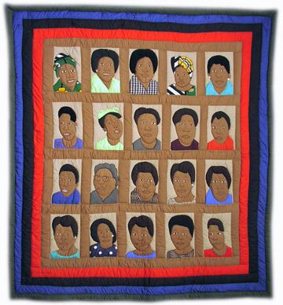

Collection of the Michigan State University Museum
More info about this quilt on the Quilt Index Website
https://quiltindex.org//view/?type=fullrec&kid=12-8-3725

(pg. 16)

Portraits of South African Black Women of t﻿he Anti-Apartheid Struggle,
by Fina Nkosi. Soweto, South Africa. 2004

The quilt incorporates portraits of Black South African women who the artist felt were instrumental in the struggle for freedom in South Africa. Depicted, left to right and with artist's original spelling in parentheses, are: (row one) Winne Mandela, Albertina Sisulu, Adelaide Tambo (Addelatte Thamo), Lindiwe [no last name give, but likely Lindiwe Nonceba Sisulu], Thandie Modise; (row two) Nokukhauya Huthuli, Lillian Masediba Nhoyi (Lillian Mosediba Ngoyi), Princess Contance Magogo (Princess Contance Magogo), Dudu Masondo, Stella Sigcau (Stell Sigcawu); (row three) Dipuwo Hanni, Florence Mkhhize (Florance Mkmize), Charlotte Maxeke, Dr. Ellen Khuzwayo, Princess Irene (Princess Irene); and (row four) Marry [sic] Nontolwane, Lillian Ntshang, Felicia Mabuza-Suttle, Rose Givamanda, and Kate [no last name given, but likely Kate Molale].

The quilt artist, Fina Nkosi, is affiliated with the Zamani Quilting Sisters of Soweto, South Africa, a group of women who, facing the double exploitation of racism and sexism, formed a self-help organization and women's resource center in 1987.
Brixton Art Gallery archive featuring the Zamani Quilting Sisters of Soweto, South Africa: https://brixton50.co.uk/zamani-soweto-sisters-textile/

Quilt Terms:
The quilt artist utilizes brown sashing between each quilt square. There are 3 borders in this quilt. What colors are they?

(pg. 17)

Quilt 5

W.P.A. Tulip, by Minnie Benberry, Kentucky c1930.

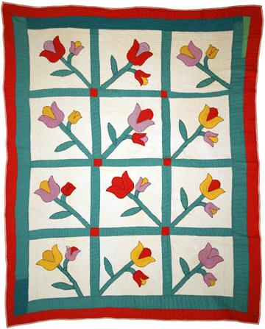

Collection of the Michigan State University Museum

More info about this quilt on the Quilt Index Website
https://quiltindex.org//view/?type=fullrec&kid=12-8-5242

(pg. 18)
W.﻿P.A. Tulip,
by Minnie Benberry, Kentucky c1930

Essay:
Minnie Benberry was Cuesta Benberry’s mother-in-law. During the Great Depression, the government hired artists and craftspersons to make quilts as a part of the Works Progress Administration (W.P.A.). Cuesta discovered that a W.P.A. social worker working in rural western Kentucky gave this quilt’s tulip pattern to quilters in the region. The farm families, scattered over a wide area, were unaware that other families had received the same pattern. When the women gathered in the spring at the churchyard to quilt their tops they were surprised that they each had used the same pattern. They decided to name the pattern “W.P.A. Tulip.”
- Quote by Mary Worrall, from the exhibit Unpacking Collections: the Legacy of Cuesta Benberry, An African American Quilt Scholar.
Read the background information about this quilt on the Quilt Index website. After reading, reflect on the following questions:
- What details or visuals do you notice in this quilt? What do they make you think about?
- What details about this quilt might give a viewer insight into the time period and/or context of the quilt or quilt maker?

(pg. 19)

Quilt 6

Bel Peyizan Lakay (Beautiful Peasant Household), by Denise Estava. Cornillon-Grand Bois, Haiti. 2010

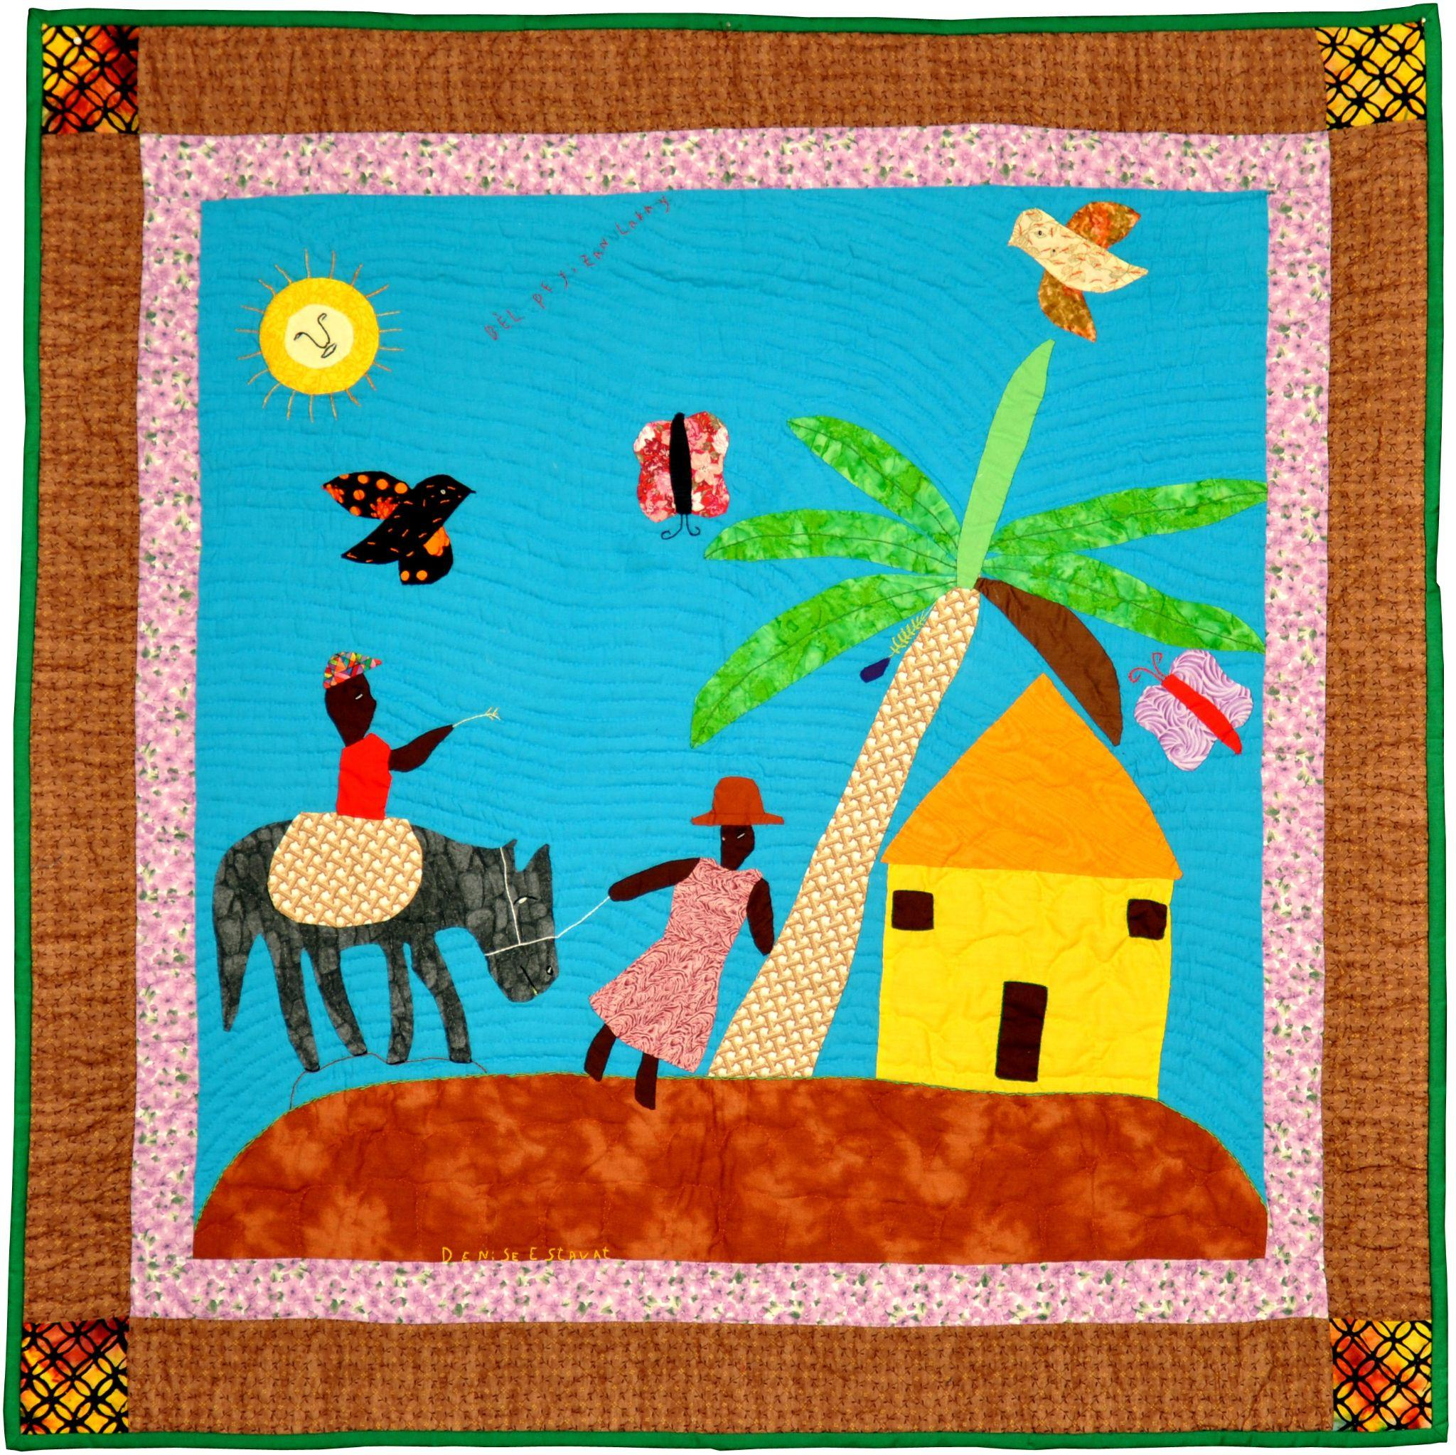

Collection of the Michigan State University Museum

More info about this quilt on the Quilt Index Website
https://quiltindex.org//view/?type=fullrec&kid=12-8-5654

(pg. 20)

Bel P﻿eyizan Lakay (Beautiful Peasant Household),
by Denise Estava. Cornillon-Grand Bois, Haiti. 2010

Read the background information about this quilt on the Quilt Index website. After reading, reflect on the following questions:
- What images, symbols, or visuals do you notice in this quilt? What do they make you think about?
- Consider the description of the quilt along with the title and visuals you have identified. Write a few sentences about the ways this quilt artist may have constructed the quilt to embody a narrative or meaning. In your writing, be sure to document details of the quilt using descriptive language. Discuss your ideas with a partner or small group.

Quilt Terms & Techniques:
The quilt artist utilizes machine piecing and hand applique techniques. The machine piecing was done on a treadle sewing machine. This quilt has 2 borders. One is a pink floral patten, and the second is brown with yellow, red, and black patterned corners. The quilt binding is green.

Quilt Inspired Activity:
This narrative quilt embodies details from the artist's desires for and vision of a beautiful, pleasant household. Take a moment to think about what a beautiful and pleasant household looks like to you. Write a few sentences about the details that are essential for your vision. Then, draw a picture that materializes your ideas. Consider coloring in your picture with markers, crayons, or colored pencils. Or, use colored paper or construction paper to make a collage of your envisioning.

(pg. 21)

Quilt 7

Todd Family History Quilt, by Deonna Todd Green & Ione Todd. Remus, MI. 1989.

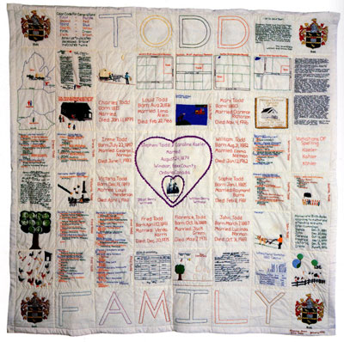

Collection of the Michigan State University Museum

More info about this quilt on the Quilt Index Website
https://quiltindex.org//view/?type=fullrec&kid=12-8-35

(pg. 22)

Todd Family History Quilt,
by Deonna Todd Green & Ione Todd. Remus, MI. 1989

Read the background information about this quilt on the Quilt Index website. After reading, reflect on the following questions:
- What images, symbols, or visuals do you notice in this quilt? What do they make you think about?
- Look closely at each quilt square. What family documents and information is listed on the quilt?
- How many generations of family are represented in this quilt?

Quilt Inspired Activity:
This family quilt embodies details from the artists' family and their history.

Questions for self-reflections and/or discussion:
- What do you know about your family, ancestors, and your family's history?
- What would you like to know about your family and ancestors?
- Is there someone in your family who keeps track of familial stories and personal information?
- What types of records or artifacts related to family do you, or other members of your family, have available? i.e. pictures, obituaries, legal documents, birth or wedding announcements, etc.
- Where are documents related to your family kept?
- Does your family have traditions for passing down information about elders and ancestors?

(pg. 23)

Quilt 8

African Colors, by Raifu Aderemi Mustapha Osogbo, Nigeria. 1998.

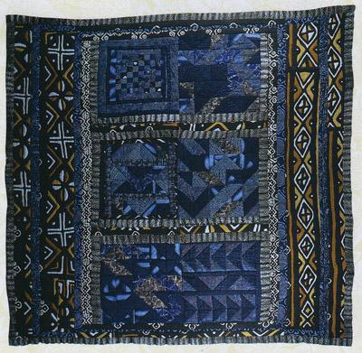

Collection of the Michigan State University Museum

More info about this quilt on the Quilt Index Website
https://quiltindex.org//view/?type=fullrec&kid=12-8-891

(pg. 24)

African Colors,
by Raifu Aderemi Mustapha. Osogbo, Nigeria. 1998

The fabric of this quilt was dyed using adire dying, a method that is used by the Yoruba people that incorporates ancient Indigo dyes with modern stitching techniques.

Read the background information about this quilt on the Quilt Index website. After reading, reflect on the following questions:
- What shapes, patterns, or symbols do you notice in this quilt? What do they make you think about?
- The quiltmaker notes that this quilt embodies their ideas about unity in Africa. Take some time to closely consider details in this quilt, then write a few sentences about the ways this quiltmaker may have utilized the colors, patterns, and materials of this quilt to embody their conceptualization of unity.

This description of this quilt notes that the quiltmaker, Raifu "Remi" Mustapha, engaged in learning about quilting at the Nike Center for Arts and Culture. The Nike Center for Arts and Culture was established in 1988 in Osogbo, Nigeria by Nike Olaniyi Davies-Okundaye. Read more about Chief Dr. Nike Olaniyi Davies-Okundaye using the link below. https://colorsxstudios.com/editorials/mama-nike

(pg. 25)

Quilt 9

Emancipation to Equality: A Long Journey Continues, by Jakki Dukes. Shaker Heights, OH. 2009

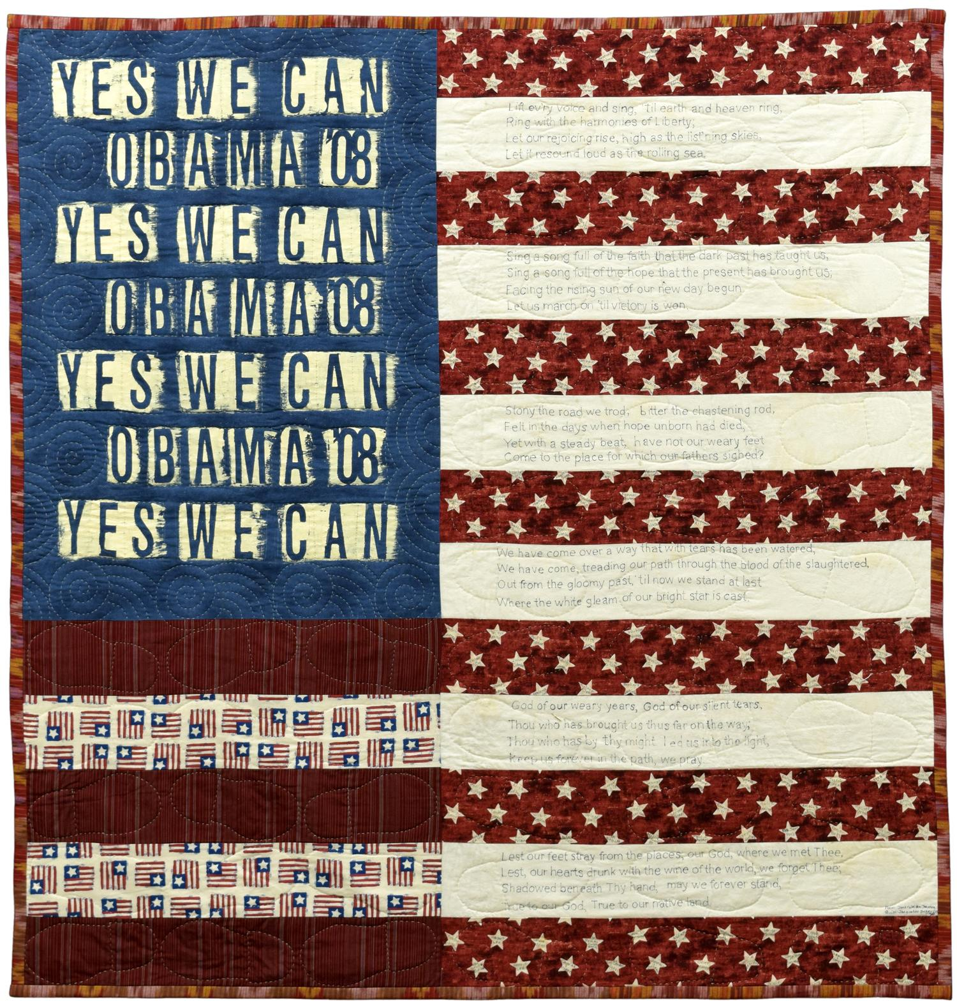

Collection of the Michigan State University Museum

More info about this quilt on the Quilt Index Website
https://quiltindex.org//view/?type=fullrec&kid=12-8-6781

(pg. 26)
Emancipation﻿ to Equality: A Long Journey Continues,
by Jakki Dukes. Shaker Heights, OH. 2009

Read the background information about this quilt on the Quilt Index website. After reading, reflect on the following questions:
- What words, images, symbols, or visuals do you notice in this quilt? What do they make you think about? Make a list of the details you are able to identify.
- Consider the description of the quilt along with the title and visuals you have identified. Write a few sentences about the ways this quilt artist may have constructed the quilt to embody a narrative or meaning. In your writing, be sure to document details of the quilt using descriptive language. Discuss your ideas with a partner or small group.

Quilt Inspired Activity:
The quilt maker utilizes footprints and stars as repeated visuals throughout the quilt. Trace the shape of the footprints used in the quilt on a piece of paper. Then, write the name of an elder or ancestor whose life and legacy has inspired you inside the footprint. Next, write a few sentences about the ways their life has inspired your own life experiences and goals in the remaining space of the footprint. If you complete this activity with a group, cut out each of your footprints, and use glue or tape to adhere each footprint to a larger background that is a contrasting color. Consider adding words, other visuals, and/or a title to the finished piece.

(pg. 27)

Quilt Pattern Activity Template
Inspired by: Emancipation to Equality: A Long Journey Continues, by Jakki Dukes. Shaker Heights, OH. 2009.

(pg. 28)

Quilt 10

The One for Eric G; Log Cabin, by Chawne Kimber Easton, Pennsylvania. 2015

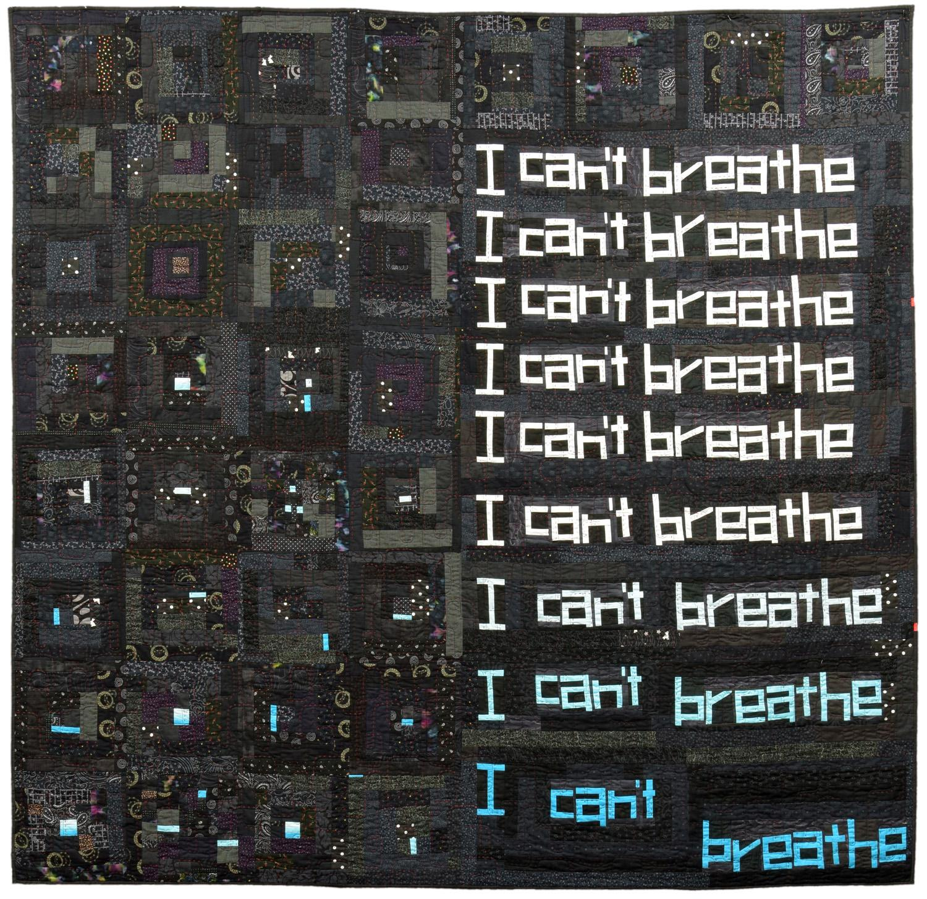

Collection of the Michigan State University Museum

More info about this quilt on the Quilt Index Website
https://quiltindex.org//view/?type=fullrec&kid=12-8-6681

(pg. 29)

The One for Eric G; Log Cabin,
by Chawne Kimber. Easton, Pennsylvania. 2015

Read the background information about this quilt on the Quilt Index website. After reading, reflect on the following questions:
- What words, images, symbols, or visuals do you notice in this quilt? What do they make you think about? Make a list of the details you are able to identify.
- Consider the description of the quilt along with the title and visuals you have identified. Write a few sentences about the ways this quilt artist may have constructed the quilt to embody a narrative or meaning. In your writing, be sure to document details of the quilt using descriptive language. Discuss your ideas with a partner or small group.

Say their Names: if you have the capacity, research the life and legacy of Eric Garner
https://exhibits.stanford.edu/saytheirnames/feature/eric-garner
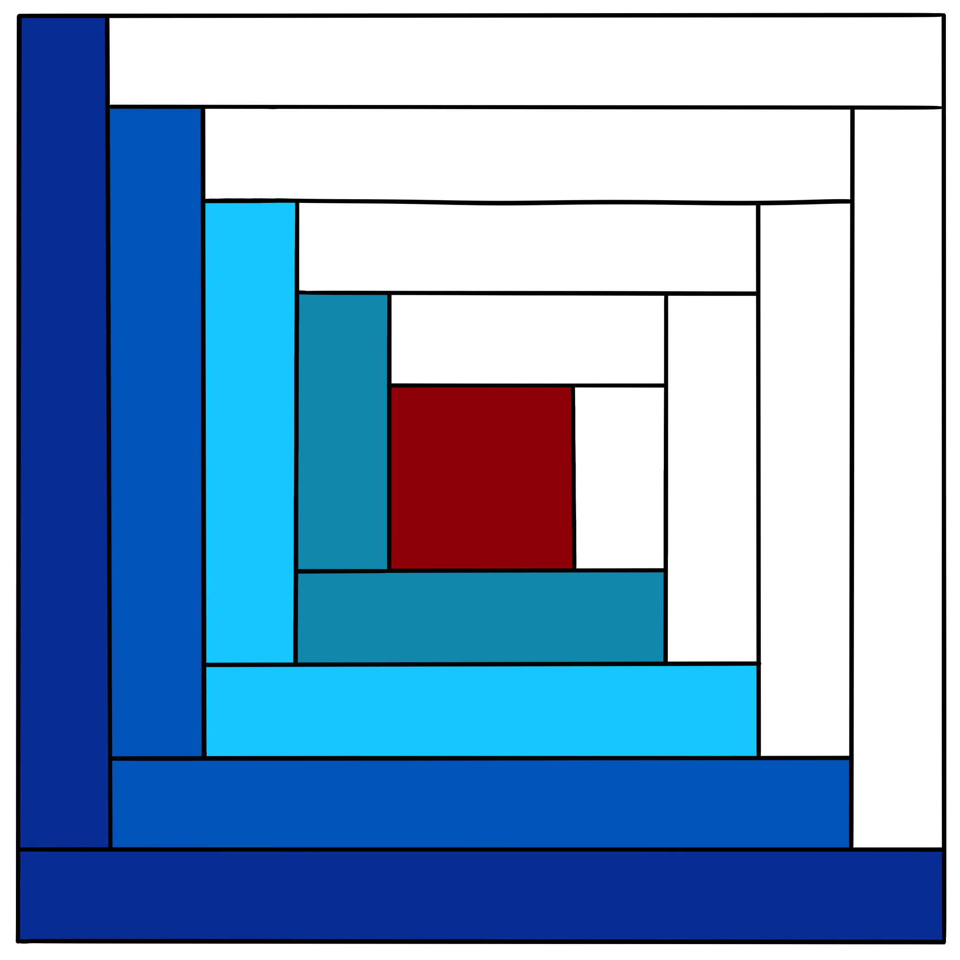

Quilt Inspired Activity:
The quilt maker utilizes a log cabin quilt block pattern throughout the quilt. Look up variations of the log cabin quilt block online. Then, using your choice of materials (colored pencils, crayons, markers, collaged pieced of paper, etc.) to fill in your own version of the outlined pattern. If you complete this activity with a group, cut out each quilt block, and use glue or tape to adhere each log cabin quilt block to a larger background that is a contrasting color. You may choose to completely cover the background, or leave space between each quilt block, similar to sashing.

(pg. 30)

Quilts from the Black Diaspora
Links to curated collection of Quilts on the Quilt Index Website

Read more info about each quilt and quiltmaker by following the links below.

Afro-American Women and Quilts, by Cuesta Benberry, Annette Ammen, Lois Mueller and the Kinloch Community Center Ladies. St. Louis, Missouri. 1979
https://quiltindex.org//view/?type=fullrec&kid=12-8-5240

Zinnia, by Leona Johnson. Monrovia, Liberia. 1992
https://quiltindex.org//view/?type=fullrec&kid=12-8-399

Tryin' to Grab a Piece of the Pie, by Carolyn Mazloomi. West Chester, OH. 1994
https://quiltindex.org//view/?type=fullrec&kid=8-5-484

Portraits of South African Black Women of the﻿ Anti-Apartheid Struggle, by Fina Nkosi. Soweto, South Africa. 2004
https://quiltindex.org//view/?type=fullrec&kid=12-8-3725

W.P.﻿A. Tulip, by Minnie Benberry, Kentucky c1930
https://quiltindex.org//view/?type=fullrec&kid=12-8-5242

Bel Peyizan Lakay (Beautiful Peasant Household),
by Denise Estava. Cornillon-Grand Bois, Haiti. 2010
https://quiltindex.org//view/?type=fullrec&kid=12-8-5654

(pg. 31)

Quilts from the Black Diaspora (contd.)
Links to curated collection of Quilts on the Quilt Index Website

Todd Family History Quilt, by Deonna Todd Green & Ione Todd Remus, MI. 1989
https://quiltindex.org//view/?type=fullrec&kid=12-8-35

African Colors, by Raifu Aderemi Mustapha Osogbo, Nigeria. 1998
https://quiltindex.org//view/?type=fullrec&kid=12-8-891

Emancipation to Equality: A Long Journey ﻿Continues
by Jakki Dukes. Shaker Heights, OH. 2009
https://quiltindex.org//view/?type=fullrec&kid=12-8-6781

The One for Eric G; Log Cabin, by Chawne Kimber Easton, Pennsylvania. 2015
https://quiltindex.org//view/?type=fullrec&kid=12-8-6681

More than 900 Quilts are linked to the Black Diaspora Quilt History Project (BDQHP) on the Quilt Index website. Use the link below to read more about the BDQHP, view quilts made by Black quilt makers, view lesson materials, and other quilt related ephemera.
https://quiltindex.org/view/?type=docprojects&kid=62-185-1

(pg. 32)

Quilt Artists

Carolyn Mazloomi
Faith Ringgold
Cuesta Benberry
Michael Cummings
Bisa Butler

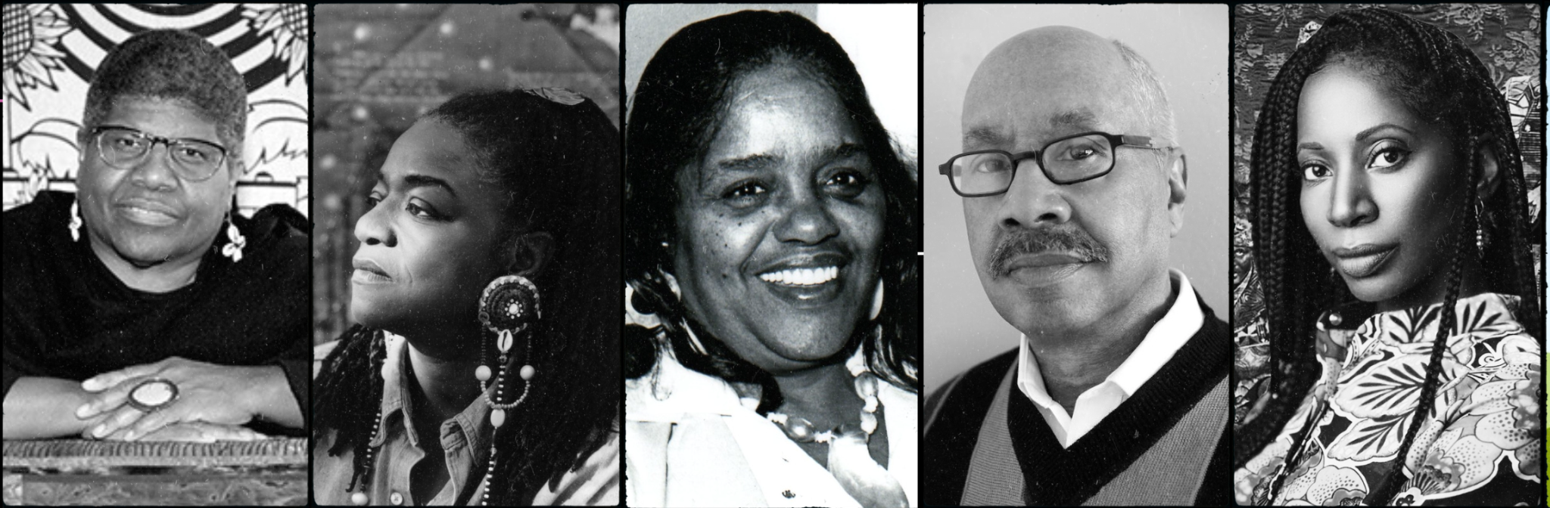

Overview
The following is a list of 5 prominent African-American quilt scholars, artists, and quilt makers.

For more information about other quilt artists listed on the Quilt Index website, use the following link: https://quiltindex.org/artists/all/

(pg. 33)

Bisa Butler

Bio
Bisa Butler is an award winning African American textile artist, born in Orange, New Jersey. She graduated with a degree in Fine Arts from Howard University, and a Masters in Art from Montclair State University. Butler was a high school art teacher for over 10 years. Butler is known for her larger than life sized quilted portraits that captivate viewers around the world with their vibrant colors, intimate embodiments of portraiture, and skillfully crafted quilting compositions.

Artist Website: https://www.bisabutler.com/

Quilts on the Quilt Index:
- Little Bits of Good https://quiltindex.org//view/?type=fullrec&kid=12-8-6878
- Free At Last https://quiltindex.org//view/?type=fullrec&kid=50-145-47
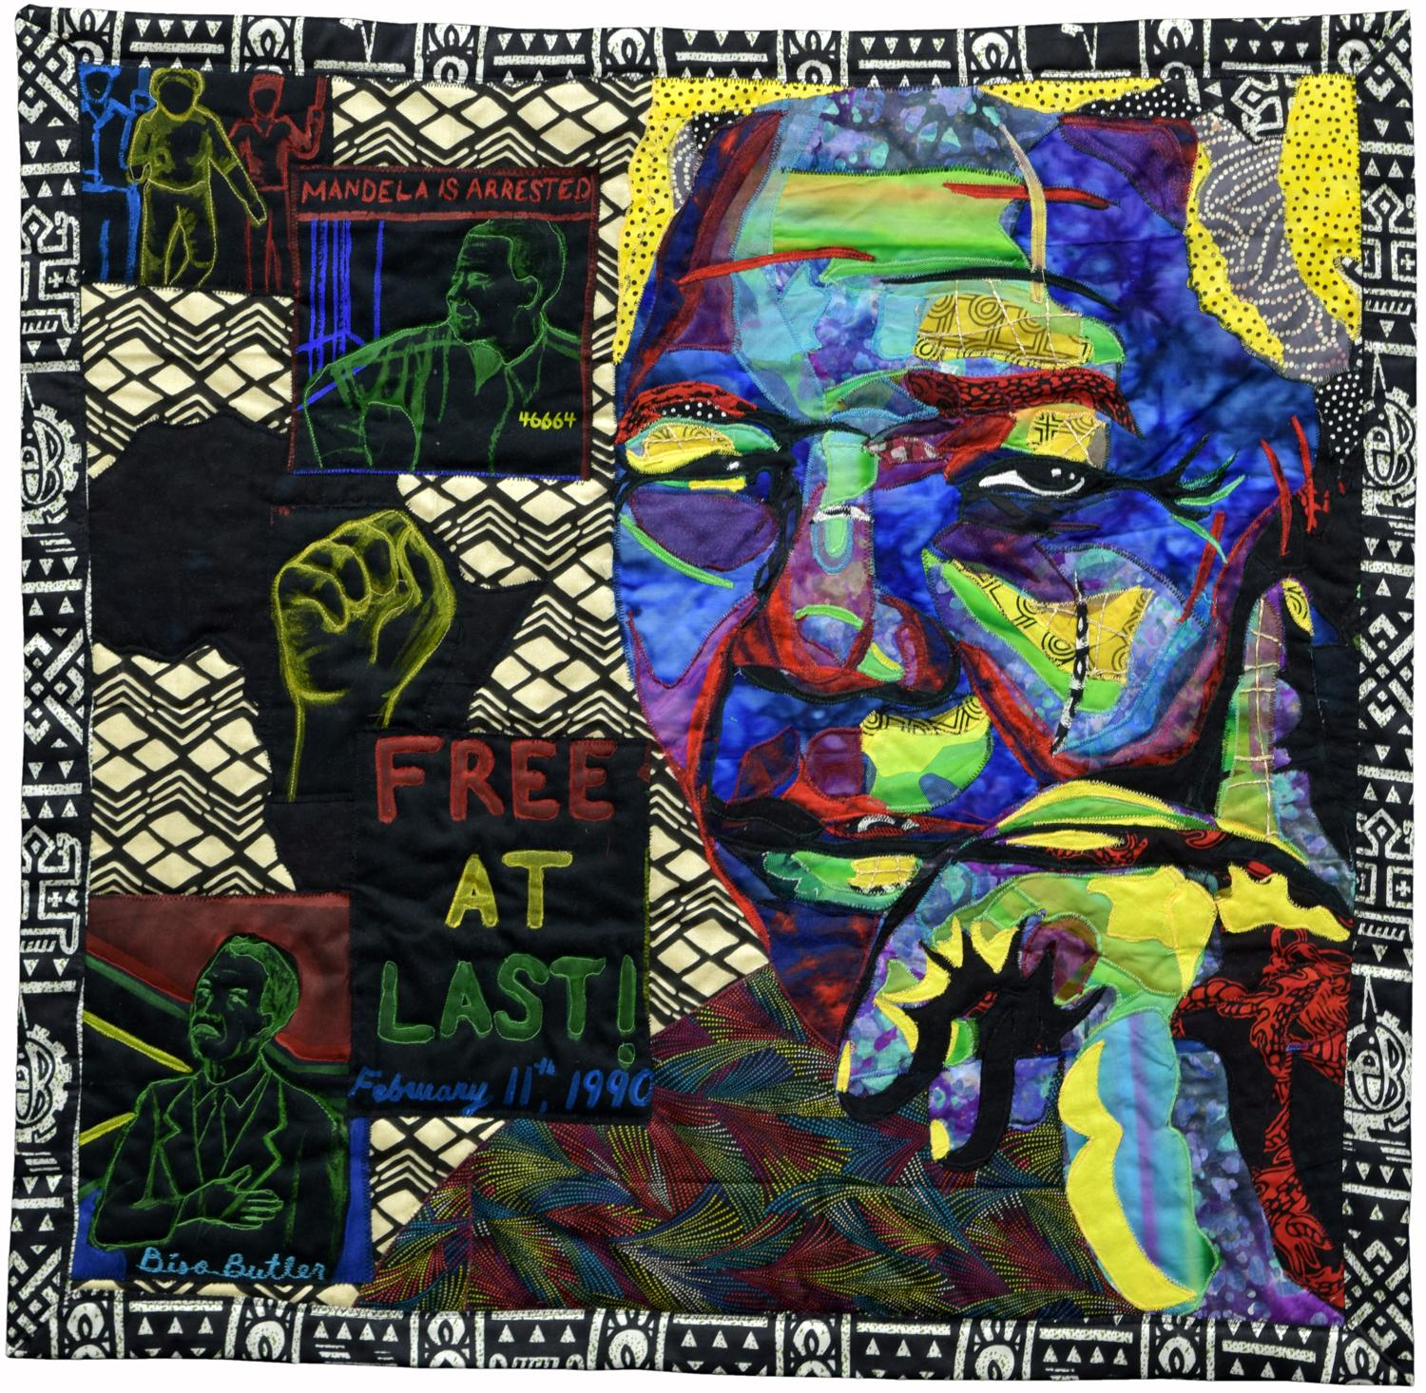

Free at Last
Bisa Butler
2014
West Orange, New Jersey
https://quiltindex.org//view/?type=fullrec&kid=50-145-47

Collection of the Michigan State University Museum

(pg. 34)

Dr. Carolyn L. Mazloomi

Bio
Dr. Carolyn Mazloomi is a quilter, historian, curator, author, lecturer, artist, and facilitator. She has a background of training in aerospace engineering. Mazloomi is the founder of the Women of Color Quilters Network (WCQN) and the African-American Quilt Guild of Los Angeles. “Mazloomi has been at the forefront of educating the public about the diversity of interpretation, styles and techniques among African American quilters as well as educating a younger generation of African Americans about their own history through the quilts the WCQN members create.” Mazloomi’s quilts and curated exhibitions have been featured nationally and around the world.

She has been honored with numerous awards and honors, including being named a National Heritage Fellow by the National endowment for the Arts in 2014, receiving a Distinguished Scholar & Celebrated Artist Lifetime Achievement Award by Faith Ringgold’s Anyone Can Fly Foundation in 2014, and being inducted into the Quilters Hall of Fame Museum in 2016.
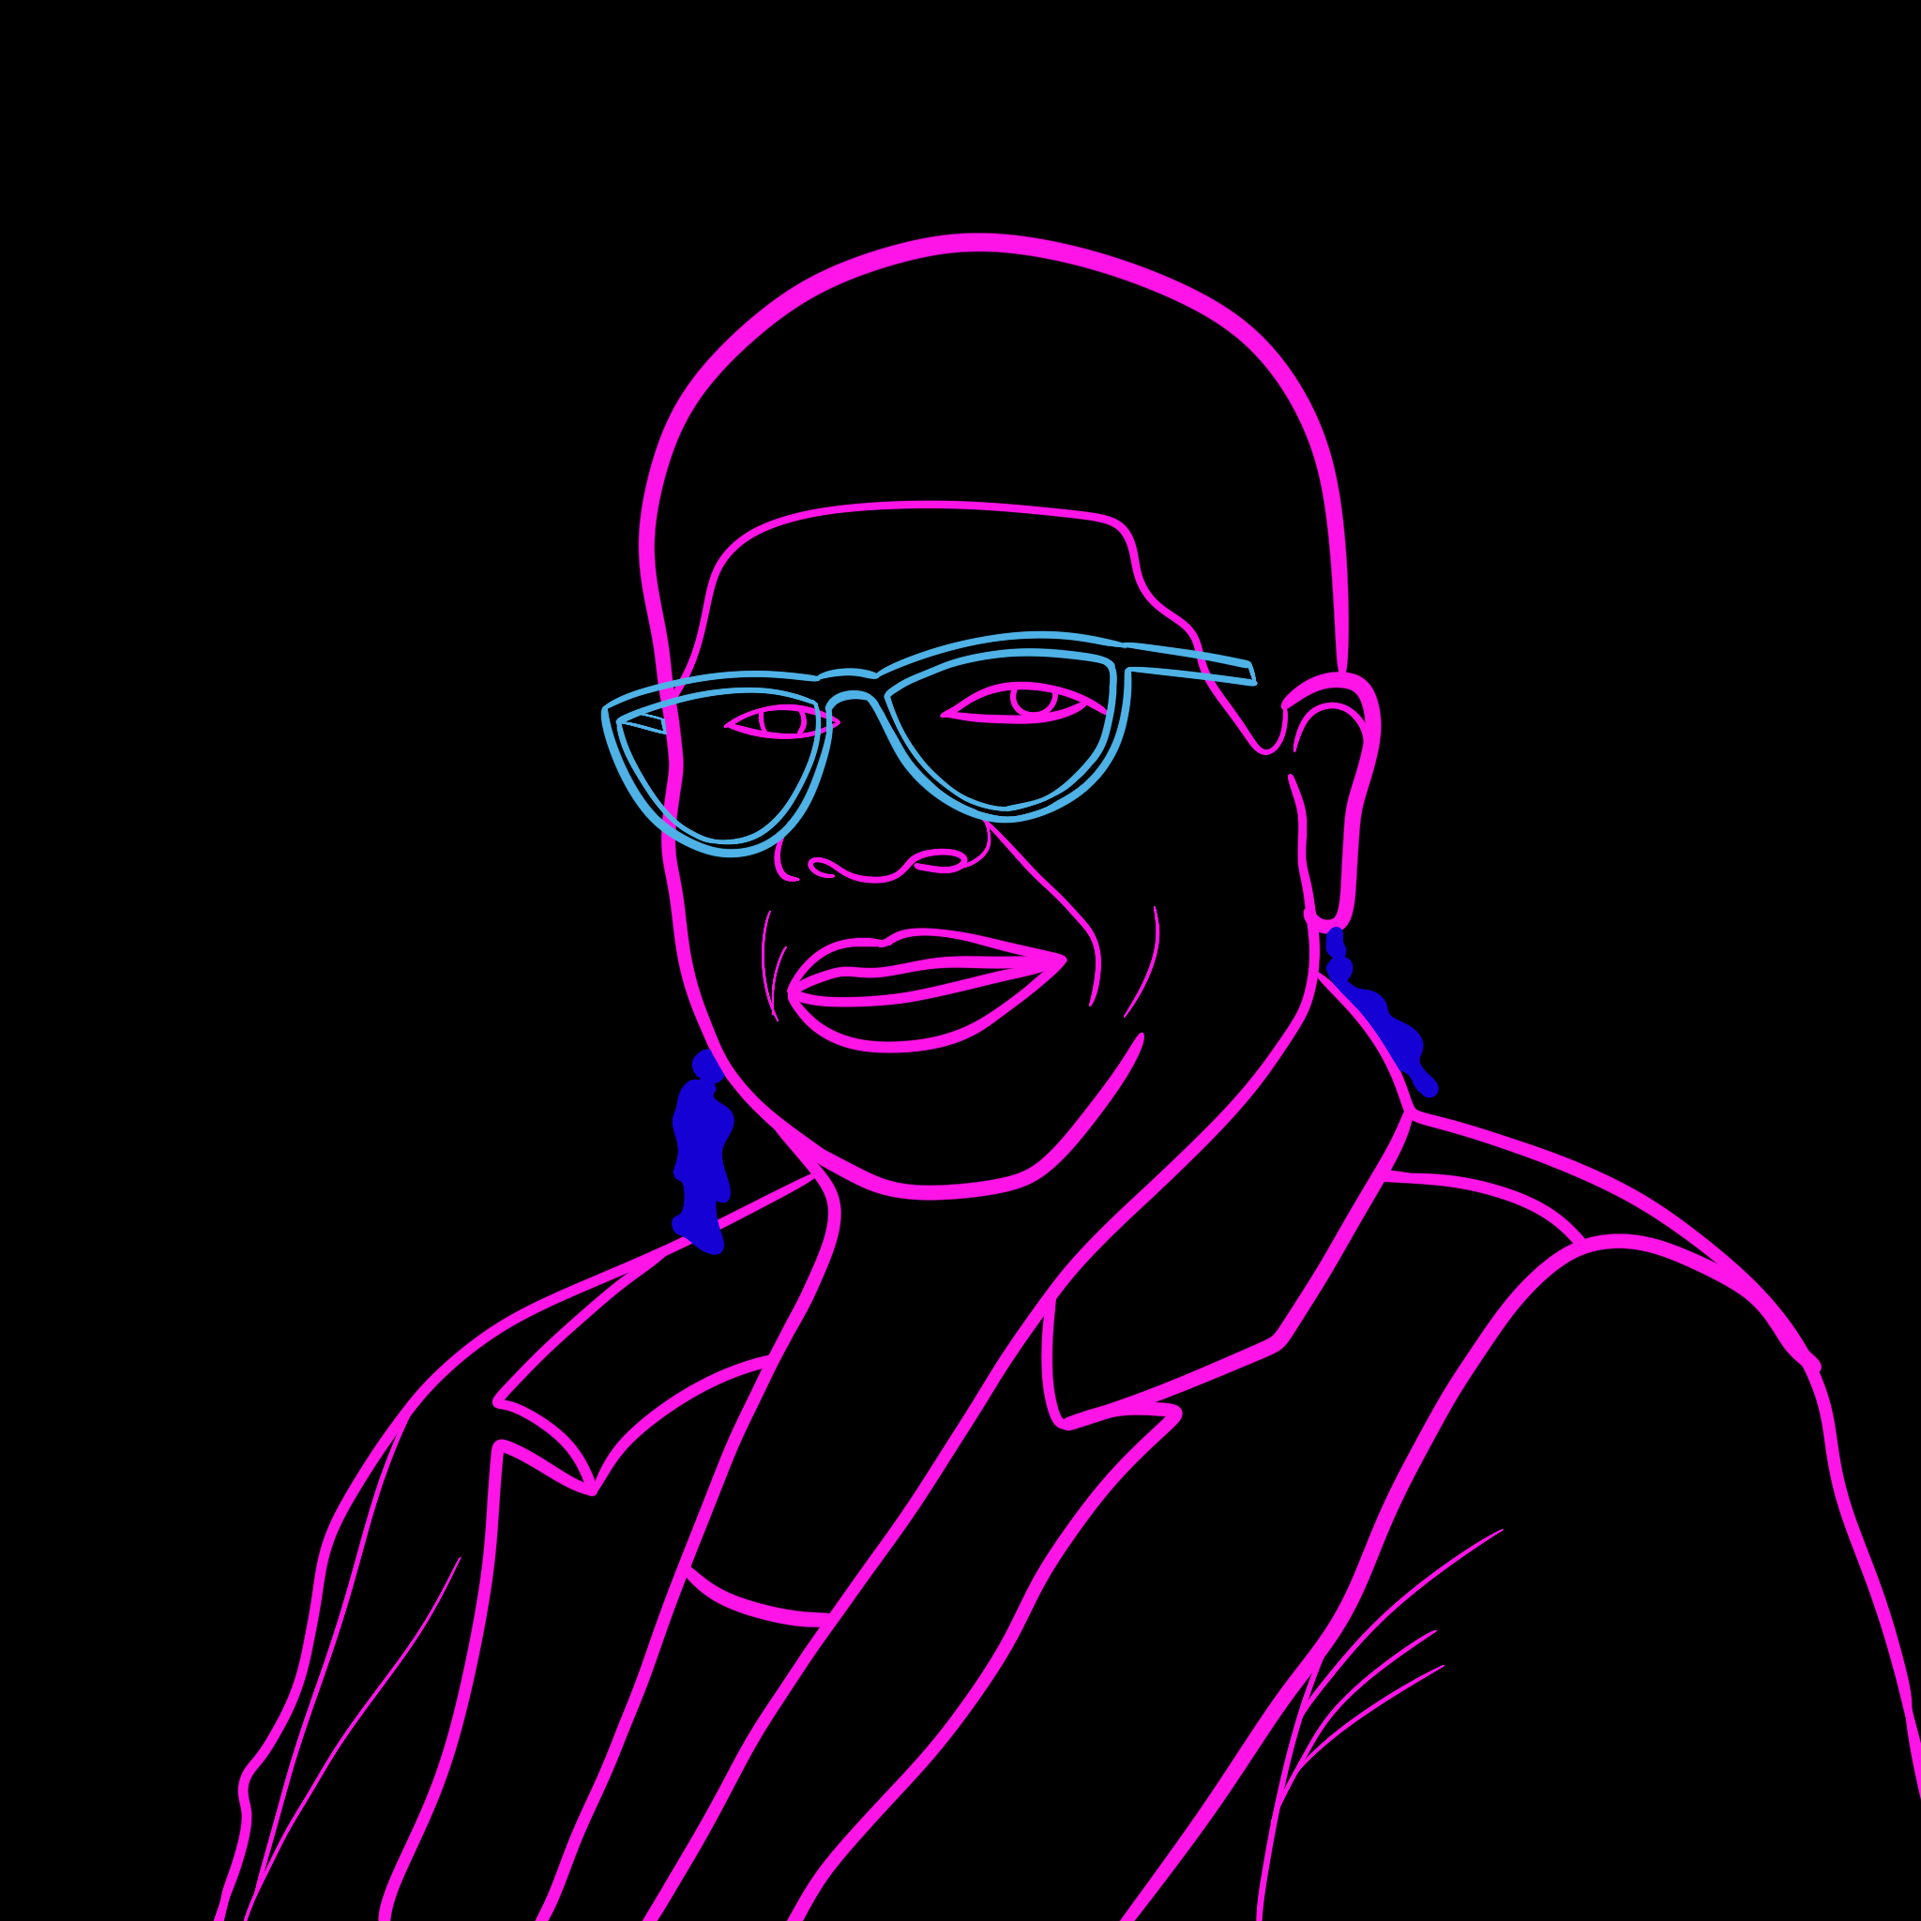

Artist Website: https://carolynlmazloomi.com/

Quilts on the Quilt Index:
- 15 Quilts by Carolyn Mazloomi https://quiltindex.org/results/?quilter=%
22Carolyn%20Mazloomi%22&search=quilts
&

(pg. 35)

Dr. Carolyn L. Mazloomi
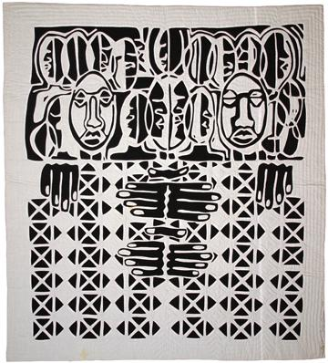

Black Family Series #1: The Family of 3
Carolyn Mazloomi
West Chester, Ohio
1996

Collection of the Michigan State University Museum
https://quiltindex.org//view/?type=fullrec&kid=12-8-5273

Women of Color Quilters Network

WCQN Website: https://wcqn.org/

WCQN on the Quilt Index:
- Overview: https://quiltindex.org/view/?type=docprojects&kid=50-146-1
- Individual Quilt Listings: https://quiltindex.org/results/?search=quilts&qproject=Women%20of%20Color%20Quilters%20Network

(pg. 36)

Cuesta Benberry

Bio
Cuesta was born on September 8, 1923 in Cincinnati, Ohio. When she was three, she moved to her grandmother’s home in St. Louis, Missouri, a city that became her lifelong home. In 1951, she married George Benberry and together they had one son, George, Jr. An introduction to her husband’s family’s quilts ignited a curiosity about the origins of the patterns and soon Cuesta embarked on what became a lifetime pursuit.

Later, Cuesta discovered and joined a network of pattern collectors who participated in pattern exchanges, including exchanges known as round robins. Because she was not a quiltmaker, many of her round robin friends not only shared a pattern but also gave her a finished quilt block. Soon she amassed both a study collection of hundreds of blocks and had established a network of friends who were also interested in quilt pattern history. Cuesta then began writing and publishing articles about quilting and pattern history in special interest publications, which were among the first anywhere to discuss topics of quilt history with intellectual and scholarly rigor. She was a founding member of the American Quilt Study Group.

As she continued researching and writing, Cuesta realized the dearth of information available about African American quilters and quilt history, and made this an intentional focus within her work. As she studied and collected information about African American quilters and quilt praxis, she began publishing about African American quilts, and serving as a consultant to nearly every major exhibition of African American quilts.

Cuesta’s work in quilt history has been honored by many awards. She was inducted into the Quilter’s Hall of Fame in 1983. In 2004, Cuesta was the recipient of the Distinguished Scholar’s Lifetime Achievement Award for her groundbreaking research on the history of African American quiltmaking, awarded by Faith Ringgold’s Anyone Can Fly Foundation.

(pg. 37)

Cuesta Benberry

Cuesta Benberry’s Archive at MSU
After her death her family offered her collection to the Michigan State University Museum due to family connections to MSU and Cuesta’s own endorsement of the MSU Museum’s continued dedication to research, collection development, education, and exhibition of quilts made by African Americans and other ethnic populations. The MSU Museum also then acquired Cuesta’s extensive collection of quilt kits. In 2009, the American Folk Art Museum, to which Cuesta had given her Euro-American quilt history collection six years earlier, transferred those collections to MSU Museum.

Cuesta Benberry Archive & Ephemera Collection on the Quilt Index Website:
https://quiltindex.org/view/?type=specialcolls&kid=12-91-465

Afro-American Women and Quilts
Cuesta Benberry, Annette Ammen, Lois Mueller and the Kinloch Community Center Ladies.
St. Louis, Mo.
2014

Collection of the Michigan State University Museum
https://quiltindex.org//view/?type=fullrec&kid=12-8-5240

(pg. 38)

Michael A. Cummings

Bio
Michael A. Cummings is an internationally renowned painter, collage artist, and self-taught quilter from Los Angeles, now residing in New York City. He was the New York Foundation for the Arts artist-in-residence from 1977 to 1979. He then joined the New York State Council on the Arts as an arts program analyst in 1980. Since retiring from the New York State Council on the Arts, he now spends much of his time researching Black history and culture, and works to embody this wealth of knowledge and stories within his construction of narrative quilts. Cummings has been recognized by many awards, commissions, and public features. Cummings’ quilts are widely collected and displayed in exhibition. He is the National Endowment for the Arts 2023 National Heritage Fellow.

Artist Website:
https://www.michaelcummings.com/

Craft in America Feature:
https://www.craftinamerica.org/artist/michael-a-cummings
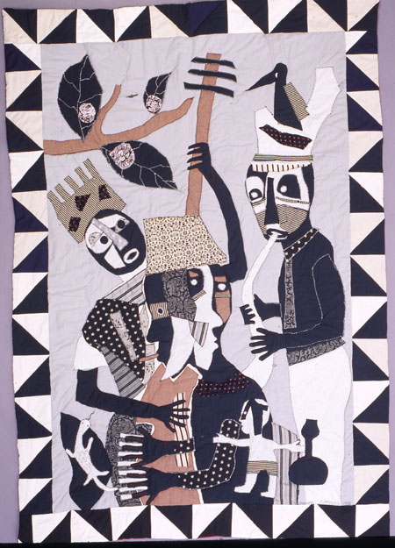

African Jazz Series #10 Quilt
Michael A. Cummings
1990
New York City, NY

https://quiltindex.org//view/?type=fullrec&kid=8-5-428

Collection of the Michigan State University Museum

(pg. 39)

Faith Ringgold

Bio
Faith Ringgold is a world renowned painter, quilter, mixed media artist, writer, teacher, and lecturer from Harlem, New York. She received both B.S. and M.A. degrees in visual art from the City College of New York, and has also been awarded more than 23 honorary Doctorates. Ringgold made her first quilt in 1980, as a collaboration with her mother, Madame Willi Posey; the quilt is titled, Echoes of Harlem. Since then, Ringgold has created an expansive collection of quilt and quilt-related artwork. Notable works include her first book Tar Beach, a children’s book based on her story quilt also titled Tar Beach, from Ringgold’s 1988 The Woman on a Bridge Series.

In 1999, Faith Ringgold founded the Anyone Can Fly foundation. This organization was created to recognize the great masters of African American art born before 1920 and to introduce these masters and their art traditions to children as well as adult audiences.
Artist Website
https://www.faithringgold.com/

Anyone Can Fly Foundation
https://www.anyonecanflyfoundation.org/

(pg. 40)

Faith Ringgold

The Faith Ringgold Study Room Collection, an archive with artifacts from Faith Ringgold’s work, is currently held in the University of Maryland David Driskell Center for the Study of Visual Arts & Culture of African Americans & the African Diaspora.

Faith Ringgold Study Room Collection:
https://driskellcenter.pastperfectonline.com/archive/054B29BB-9E69-4250-B45B-945621440559

Kiss 1, Kiss 2; from the Love Letter Series
Faith Ringgold
1987
Englewood, New Jersey
https://quiltindex.org//view/?type=fullrec&kid=12-8-5260
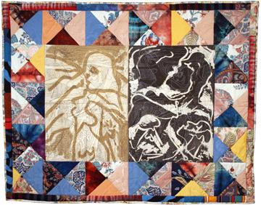
Collection of the Michigan State University Museum

(pg. 41)

Quilt Artists: Prompts to Deepen Learning

- Choose one or more of the quilt artists listed in this guide and search for information about their art, life experiences, and the inspirations. for their work. Take notes on what you find, and document your sources as well.
  - Consider making a collage or quilt square to embody one or more pieces of information that you collect.
- Is there anyone in your family or community who quilts? If so, ask them if they would like to share their stories about quilting. Ask for permission to write notes about their quilting experience, and respect their wishes. A few questions to prompt conversation are listed below.
  - How long have you quilted?
  - Who taught you to quilt? & Who do you quilt with?
  - Why do you quilt? & How does quilting make you feel?
  - Is quilting important to you? If so, why?
  - What types of quilts have you made?
  - Who do you make quilts for?

(pg. 42)

Quilt Artists: Sharing Stories Using the Quilt Index Website

- Would you like to share images and information on the Quilt Index website about one or more quilts that you or a loved one has made? If so, check out the link to our Submit A Quilt page below.
  - https://quiltindex.org/add-quilts/submit-form/

Individual quilt artists with one or more quilts listed on the Quilt Index website can also create artist pages to share biographical information related to their life and quilt praxis. This information can be submitted using "The Quiltmaker Artist" section of the Submit A Quilt page (pictured below).

(pg. 43)

More Quilt Artists

Binding Us Together: Quilts of the African Diaspora: Individuals, Organizations, & Resources. Guide by Tracy Crawford.
- https://libguides.nypl.org/quilts_african_diaspora/resources
  - full list with links, including list of National Endowment for the Arts Heritage Fellows.

(pg. 44)

Quilt Artists

- Kyra Hicks
  - https://blackthreads.com/
  - Instagram: @kquilt https://www.instagram.com/kquilt/
- Myrah Brown Green
  - https://myrahbrowngreen.com/welcome
  - Instagram: @myrahbrowngreen https://www.instagram.com/myrahbrowngreen/
- Adrienne Cruz
  - https://www.adrienecruz.com/
- Sandra Hankins
  - https://www.studiosanteenaonline.com/
  - Instagram: @sandrahankins https://www.instagram.com/sandrahankins/?hl=en
- Dr. Aliea Brown (Quilt Scholar)
  - Instagram: @CollardStudies https://www.instagram.com/collardstudies/
- Dr. Sharbreon Plummer
  - https://sharbreonplummer.com/
- Carole Lyles Shaw
  - https://carolelylesshaw.com/
  - Instagram @carole_lylesshaw https://www.instagram.com/carole_lylesshaw/
- Michael C. Thorpe
  - http://michaelcthorpe.com/
  - Instagram: @iversonsdurag https://www.instagram.com/iversonsdurag/

(pg. 45)

Quilt Artists
- Dr. Chawne Kimber
  - https://www.instagram.com/cauchycomplete/?hl=en
- Dr. Diana N’Diaye
  - https://independent.academia.edu/DianaNDiaye
  - https://theafricanamericanfolklorist.com/articles/folklorist-of-the-month-diana-baird-ndiaye
- Karen Hampton
  - https://www.kdhampton.com/
- Harriet Powers
  - https://americanhistory.si.edu/collections/search/object/nmah_556462
  - https://www.blackpast.org/african-american-history/harriet-powers-1837-1910/
- Ira Blount
  - https://www.si.edu/object/blue-flower-quilt:acm_2011.0004.0134
  - https://youtu.be/Y7NG3KzWW9I
- Marquetta Bell-Johnson
  - https://www.youtube.com/watch?v=dgGBrwabVUw&t=6s&ab_channel=SmithsonianFolklife
- Mother Cyborg
  - Instagram: @mothercyborg https://www.instagram.com/mothercyborg/
  - https://omny.fm/shows/stateside/artist-mother-cyborg-on-digital-legacy

(pg. 46)

Quilt Communities

African American Quilt groups listed on the Women of Color Quilters Network (WCQN) website: https://wcqn.org/african-american-quilt-guilds/

(pg. 47)

Quilt Groups

- African American Quilt and Doll Guild, Warrensville Heights, OH
  - https://www.aaqdg.org/
- African American Quilt Guild, Gaston County, NC
- African American Quilt Guild, Oakland, CA
  - https://www.aaqgo.org/AAQGO/
  - https://www.actaonline.org/profile/african-american-quilt-guild-of-oakland/
- African American Quilters, Baltimore, MD
  - https://www.aaqb.org/
- African-American Quilters, Los Angeles, CA
  - https://www.easysite.com/aaqla
- African American Quilting Circle, Durham, NC
  - https://www.facebook.com/AAQC.Durham.NC
- Akoma Ntoso Modern Quilt Guild of Central Indiana
  - https://www.akomantosoin.com/about-us
  - https://www.youtube.com/watch?v=ZUu5UnD5mOs&t=1s&ab_channel=TonyJeanDickerson
- Brown Sugar Stitchers Quilt Guild
  - P.O. Box 361252, Decatur, GA 30036-1252
  - https://bssquiltguild.com/
- Black Women Stitch
  - https://blackwomenstitch.org/
Black Women Stitch is the Sewing Group where Black Lives Matter. Founded by Lisa Woolfork.
- Clara Ford Foundation, Atlanta, GA
- Great Lakes African American Quilters Network
  - https://www.glaaqn.com/

(pg. 48)

Quilt Groups (contd.)

- Harlem Needle Arts, Inc.
  - https://www.facebook.com/profile.php?id=100064860487781
- Mississippi Cultural Crossroads
  - http://www.msculturalcrossroads.org/
- Needle Rules! Society, Detroit, MI
  - https://needlerules.tripod.com/
- Nubian Heritage Quilters Guild
  - http://www.nubianquilters.org/
- Pacific Northwest African American Quilters
- Princeton Sankofa Stitchers Modern Quilters Guild
  - https://www.facebook.com/PSSMQG/
  - https://www.youtube.com/watch?app=desktop&v=v0qR5t4j3hA&ab_channel=PrincetonPL
- Rocky Mountain Wa Shonaji Quilt Guild, Denver, CO
  - https://washonaji.org/
- San Diego People of Color Quilt Guild
  - https://www.facebook.com/SDPOCQG/
  - https://www.sccqg.org/san-diego-people-of-color-quilt-guild.htm
- Sisters in Stitches Joined by the Cloth, Holbrook, MA
  - https://www.sistersinstitches.org/
- Sisters of the Cloth Quilting Guild, Fort Wayne, IN
  - http://www.sistersofthecloth.org/Sisters%20of%20the%20Cloth/Welcome.html

(pg. 49)

Quilt Groups (contd.)

- Sisters Quilting Collective, Sacramento, CA
  - https://www.facebook.com/SistersQuiltingCollectiveSQC/
  - https://www.sqcsac.com/
“The Sisters Quilting Collective is a collective of 43 fiber artists based in Sacramento, CA. The nonprofit organization is primarily comprised of African American women who use quilts to promote African American quilting and quilt history."
- Stitches From the Soul-Sistahs, Toledo, OH
  - https://stitchesfromthesoulsistahs.webs.com/
- Tutwiler Quilters, Tutwiler, MS
  - http://tutwilerquilters.org/
- Uhuru Quilters Guild, Clinton, MD
  - https://www.uhuruquiltersguild.org/
- Women of Color Quilters’s Network (WCQN)
  - https://wcqn.org/ ﻿
- Zuri Quilters Guild, Nashville, TN
  - http://zuriquiltersguild.blogspot.com/
  - https://www.facebook.com/@Zuri-Quilting-Circle-100057778834880/?paipv=0&eav=AfZzUqvjbQeK1vAQUNOXDyix8xUQ7rVpDkBEkYXRSz5JumHFG0fCWYdvPCkIat2WZ-g&_rdr
  - Article about the guild: https://www.nashvillescene.com/arts_culture/coverstory/piecing-together-zuri-quilting-guilds-10-years-of-being-black-and-beautiful-in-nashville/article_662e7102-e68f-5d04-b128-14043c5e70ec.html

(pg. 50)

Quilt Index

Quilt Scholarship
a curated selection of books, articles, dissertations, literature, blogs, videos, exhibitions, special collections, & podcasts about Black quilters and their quilts

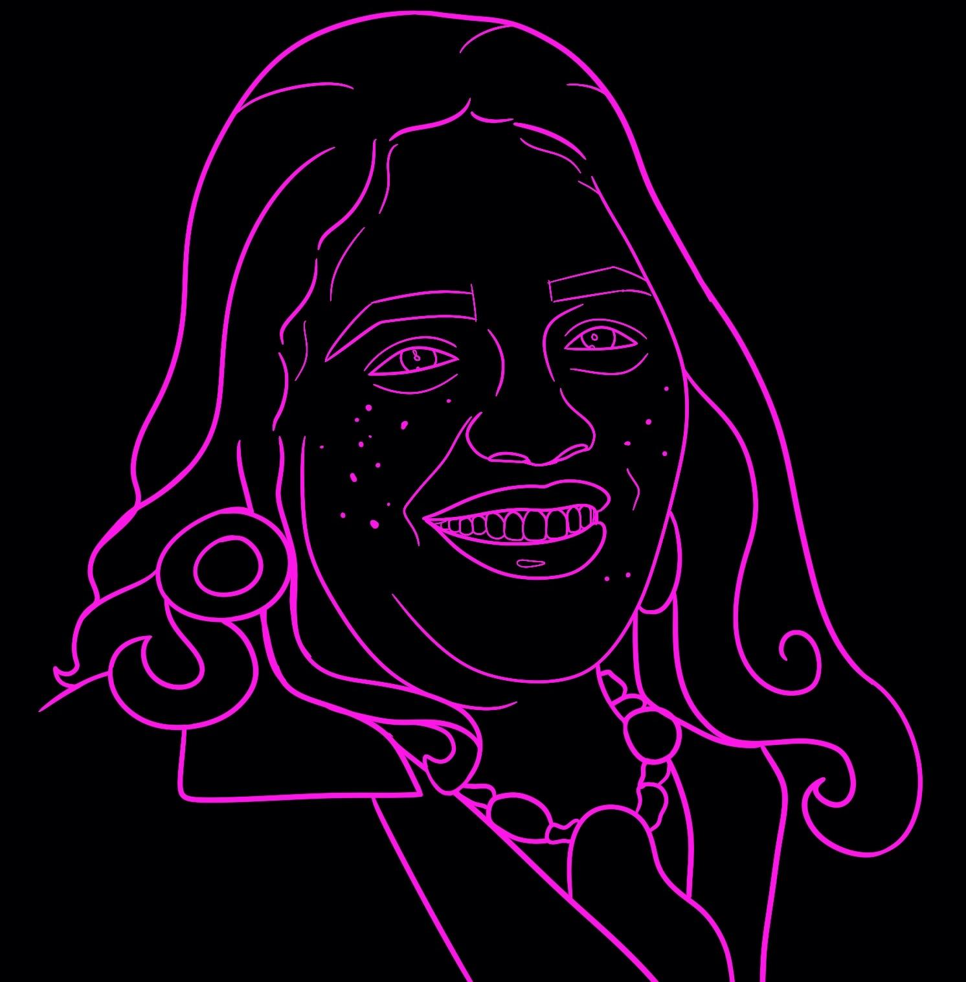
Cuesta Benberry

(pg. 51)

Books

- Benberry, Cuesta. 1992. Always there: The African-American presence in America. Louisville, Ky: Kentucky Quilt Project.
- Fry, Gladys-Marie. 1990. Stitched from the Soul: Slave quilts from the Ante-bellum South. New York: Dutton Studio Books.
- Freeman, Roland L. 1996. A Communion of the Spirits: African-American Quilters, Preservers, and Their Stories. Nashville, TN: Rutledge Hill Press.
- Hicks, Kyra E. 2003. Black Threads: an African American Quilting Sourcebook. Jefferson, N.C.: McFarland & Co.
- Mazloomi, Carolyn. 1998. Spirits of the Cloth: Contemporary African-American Quilts. New York: Clarkson Potter Publishers.
- Plummer, Sharbreon. 2022. Diasporic Threads: Black Women, Fibre & Textiles. Common Threads Press.
- The Great Lakes African American Quilters' Network. 2017. Everlasting Threads: Honoring Heritage and History. CreateSpace Independent Publishing Platform.

More quilt books by Carolyn Mazoomi:
https://carolynlmazloomi.com/publications/

(pg. 52)

Articles & Dissertations

Binding Us Together: Quilts of the African Diaspora: Articles & Essays (full list with links).
https://libguides.nypl.org/quilts_african_diaspora/articles

- Brown, Aleia M. (2016). "War and Redemption in the Cloth: Quilting the Black Freedom Struggle, 1960- Present." Middle Tennessee State University.
- Butler, Alana. (2019). “Quiltmaking Among African-American Women as a Pedagogy of Care, Empowerment, and Sisterhood.” Gender and Education, 31:5, 590-603, DOI: 10.1080/09540253.2019.1594708
- Hood, Yolanda. (2001). “The Culture of Resistance: African American Art Quilts and Self-Defining.” Uncoverings, 22, 141-170. http://www.quiltindex.org/journals/article.php?Akid=2-B-52
- Beck Cohen, S. (2023). Quilting in West Africa: Liberian Women Stitching Political, Economic, and Social Networks in the Nineteenth Century. Arts, 12(3), 97.
MDPI AG. Retrieved from http://dx.doi.org/10.3390/arts12030097

(pg. 53)

Articles & Dissertations

- NPR, Black Lives Are Celebrated In Bisa Butler's Extraordinary, Technicolor Quilts, By Cheryl Corley.
  - https://www.npr.org/2021/08/15/1025950962/black-lives-are-celebrated-in-bisa-butlers-extraordinary-technicolor-quilts
- The Radical Quilting of Rosie Lee Tompkins, by Roberta Smith.
  - https://www.nytimes.com/interactive/2020/06/26/arts/design/rosie-lee-tompkins-quilts.html
- For Generations, African American Women Have Used Quilting as a Powerful Tool of Survival, Resistance, and Artistic Expression, By Colony Little.
  - https://www.artnews.com/list/art-news/artists/contemporary-textile-quilting-artists-to-know-1234647693/

(pg. 54)

Literature
- Walker, Alice. 1973. “Everyday Use.”
  - https://harpers.org/archive/1973/04/everyday-use/

Blogs
- Carole Lyles Shaw
  - https://carolelylesshaw.com/blog/
- Princeton Sankofa Stitchers Modern Quilt Guild
  - https://sankofastitchers.blogspot.com

Podcasts
- The Stitch Please Podcast: the official podcast of Black Women Stitch, the sewing group where Black lives matter.
  - https://blackwomenstitch.org/topic/podcast
- Tangular Irby’s Legacy of Our African American Lives Podcast, Episode 5: “Telling Black Stories with Care,” with Dr. Aleia Brown.
  - https://legacy-of-our-african-a.captivate.fm/episode/telling-black-stories-with-care-w-aleia-brown

(pg. 55)

Videos

- Binding Us Together: Quilts of the African Diaspora: Documentaries & Interviews
  - https://libguides.nypl.org/quilts_african_diaspora/documentaries
- African American Modern Quilt Guilds, Carole Lyles Shaw
  - https://www.youtube.com/watch?v=UYV3ANFERVc&t=931s&ab_channel=CaroleLylesShaw
- Celebrating 20 Years of Quilting: The Story of Durham's African American Quilt Circle (AAQC)
  - https://www.youtube.com/watch?v=E7vS_eo32Hs&t=2364s&ab_channel=ScholarsandPublics
In this wide-ranging public conversation, Marjorie Diggs Freeman, Jereann King Johnson, and Sauda A. Zahra, all members of the African American Quilt Circle (AAQC) of Durham, North Carolina, discuss how the group got started, its history of community engagement, how politics informs its art, the history of Black quilting, and the future of the form. Fellow AAQC member Kim F. Hall moderates.

(pg. 56)

Videos

- International Quilt Museum | Power, Purpose, + Perseverance: Visualizing Black History in Quilts by Dr. Carolyn Mazloomi
  - https://www.youtube.com/watch?v=ToXLhP7LiMg&ab_channel=InternationalQuiltMuseum
- Toledo Museum of Art | Bisa Butler and Carolyn Mazloomi Chat
  - https://www.youtube.com/watch?v=-qaLzjCI8EY&ab_channel=ToledoMuseumofArt
Explore the preservation of African American stories through quiltmaking with contemporary artist Bisa Butler and author, artist, and quilt historian Dr. Carolyn Mazloomi as they discuss how history along with current calls for racial justice have inspired their work.
- American Folk Art Museum | Virtual Insights: Bisa Butler in Conversation with Dr. Myrah Brown Green
  - https://www.youtube.com/watch?v=hOso0gbBP8I&ab_channel=AmericanFolkArtMuseum
Hear more about their art and activism, the exchange of generational memory, and their responses to selected works from the museum’s permanent collection. A Q&A session follows the conversation.

(pg. 57)

Videos

- Berkeley Art Museum | African American Quilt Guild of Oakland: Why I Quilt
  - https://www.youtube.com/watch?v=dZ0vVNR5BbA&t=3s&ab_channel=BerkeleyArtMuseum%26PacificFilmArchive
Three celebrated members of the AAQGO, Frances Porter, Teri Green, and LaQuita Tummings, host a studio visit to address the question “Why I Quilt,” explaining how they became quilters, sharing their quilt journeys, and displaying some of their creations.

(pg. 58)

Museums & Collections

- Schomburg Center for Research in Black Culture | Binding Us Together: Quilts of the African Diaspora Guide
  - https://libguides.nypl.org/quilts_african_diaspora/home
- National Quilt Museum
  - https://quiltmuseum.org/
- International Quilt Museum
  - https://www.internationalquiltmuseum.org/
- African American Collection:
  - https://www.internationalquiltmuseum.org/collection/african-american
- Quilt Index
  - https://quiltindex.org/
- Cuesta Benberry’s Archive & Exhibition @ the MSU Museum
  - https://museum.msu.edu/?exhibition=unpacking-collections-the-legacy-of-cuesta-benberry-an-african-american-quilt-scholar
- Gladys Marie Fry’s archive at the MSU Library
  - https://libguides.lib.msu.edu/Gladys-MarieFry
  - Finding Aid: https://findingaids.lib.msu.edu/repositories/4/resources/6345

(pg. 59)

Museums & Collections

- African American Quilts, Smithsonian Institution
  - https://anacostia.si.edu/collection/spotlight/african-american-quilts
- Montgomery Museum of Fine Art, Textiles
  - https://collection.mmfa.org/objects-1/tiny_thumbnails?records=500&query=Portfolios%20%3D%20%22985%22&sort=0
- American Folk Art Museum, Textile Collection
  - http://collection.folkartmuseum.org/collections/594/textiles/objects
- Old State House Museum, African American History Collection (includes African American Quilts)
  - https://collections.oldstatehouse.com/collections/17460/arkansas-africanamerican-history-collection/objects
- Eli Leon Collection, University of California, Berkeley Art Museum & Pacific Film Archive (BAMPFA)
  - https://bampfa.org/news/bampfa-receives-historic-bequest-nearly-three-thousand-quilts-african-american-artists “Comprising nearly three thousand works by African American quilt makers, including more than five hundred works by the internationally renowned artist Rosie Lee Tompkins, the Eli Leon Collection marks one of the largest bequests of African American art ever donated to a US museum.”

(pg. 60)

Exhibitions

- Binding Us Together: Quilts of the African Diaspora: Exhibition Catalogs (list with links)
  - https://libguides.nypl.org/quilts_african_diaspora/exhibitions
- Virtual Exhibition: Uncovering Black History: Quilts from the collection of Carolyn Mazloomi
  - https://my.matterport.com/show/?m=CUtdNrDpGv4&back=1
  - https://www.internationalquiltmuseum.org/exhibition/uncovering-black-history-quilts-collection-carolyn-mazloomi
- “Soulful Stitching: Patchwork Quilts by Africans (Siddis) in India,” Curated by Henry Drewal
  - https://www.henrydrewal.com/exhibit_stitching_history.html
- “Stitching the Transatlantic: Liberian Quilts from the John Singler Collection” at the International Quilt Museum, University of Nebraska-Lincoln. Stephanie Beck Cohen, Guest Curator.
  - https://www.internationalquiltmuseum.org/exhibition/stitching-transatlantic-liberian-quilts-john-singler-collection
- Museum of the Gulf Coast, African American Quilters of the Gulf Coast. Oct. 1-Dec. 3. 2022.
  - https://visitportarthurtx.com/blog/african-american-quilters-of-the-gulf-coast/

(pg. 61)

Exhibitions

- Museum of Fine Arts Boston, Fabric of a Nation: American Quilt Stories. Oct. 10, 2021–Jan. 17, 2022.
  - https://www.mfa.org/exhibition/fabric-of-a-nation
- Ocean City Arts Center, Stitched Stories: an Exhibition of NJ African American Quilters. JUL 01, 2022 - JUL 29, 2022
  - https://www.mutualart.com/Exhibition/Stitched-Stories--an-Exhibition-of-NJ-Af/43549BB6D1AC5254
- Conscience of the Human Spirit: The Life of Nelson Mandela
  - https://quiltindex.org//view/?type=exhibits&kid=50-147-1 This exhibition features quilts made in tribute to Nelson Rolihlahla Mandela, after his passing. This exhibition was developed by the Michigan State University Museum and the Women of Color Quilters Network in association with quilt artists across South Africa. These diverse and often powerful pieces reflect the ways in which this remarkable man touched individual lives, changed a nation, and literally served as the conscience of the human spirit for individuals around the world. Curated by Marsha MacDowell, Ph.D. & Carolyn Mazloomi, Ph.D.

(pg. 62)

Quilt Conferences

- Stitch by Stitch
  - https://www.stitchingabolition.com/
  - Stitch x Stitch is a convening situated within a long historical conversation between quilting and social justice. Textile artists have long engaged with quilting and community crafting practices to advocate for the abolition of criminalization and incarceration. Abolitionist quilters have used imagery and embroidered text, as a means of swaying public opinion and troubling state level policies that promote notions of “order and justice” through criminalization. Through politically charged work, artists have long highlighted the intersection of racial capitalism and trauma and the disproportionate impact of police violence, criminalization and incarceration on communities of color. We seek to explore how quilting can serve as an embodied, liberatory practice and the role it plays in facilitating new forms of liberation. We also wish to interrogate definitions of "healing," both productive and problematic, and its intersections with quilting and work of the hand.
  - Organizers: Sharbreon Plummer, Savneet Talwar, Rachel Wallis
- QuiltCon
  - https://quiltcon.com/
  - Presented by, The Modern Quilt Guild

(pg. 63)

Organizations & Initiatives

- Runaway Quilt Project: Digital Humanities Exploration of Quilting During Slavery, by Deimosa Webber-Bey
  - http://runawayquiltproject.org/
- African American Quilt Documentation Study Group (AAQDSG), led by Adonna Richardon
  - www.SewBlessed.Online “A place to discuss African American Quilt History and Quilt Documentation for the preservation of family heritage”
- The Legacy Quilt
  - https://www.mofad.org/the-legacy-quilt “The Legacy Quilt is a handmade quilt composed of 406 blocks, each one representing one African American contribution to American cuisine. Standing at 14 feet tall and nearly 30 feet wide, this awe-inspiring object makes a powerful point: there are countless stories that deserve recognition.”
- Aids Memorial Quilt | NAMES Project Foundation
  - https://www.aidsmemorial.org/quilt The Quilt was conceived in November of 1985 by long-time human rights activist, author and lecturer Cleve Jones.Jones teamed up with Mike Smith, Gert McMullin and several others in 1987 to formally organize the NAMES Project Foundation. Their goal was to create a memorial for those who had died of AIDS, and to thereby help people understand the devastating impact of the disease.

(pg. 64)

Organizations & Initiatives

- Harlem Needle Arts
  - https://harlemneedlearts.org/ “Harlem Needle Arts (HNA) is an arts and cultural organization at the forefront of revolutionizing, preserving, and expanding the narrative of fiber, textile, design, and needle arts in the African Diaspora through exhibitions, education, technical support, economic development and other tools. HNA’s artistic vision of needle arts, enhances identity, promotes dexterity and pride in one’s ability to create through rhythmic art forms fusing history and art therapy.”
- African American Craft Initiative
  - https://folklife.si.edu/african-american-craft?fbclid=IwAR0GnAQKiGoEH3iFkQYJjbLvm3gZNGk4DNGg7IhJ76A3rcR7FByKi5vc2kU#publications “The African American Craft Initiative (AACI), launched in 2020 in response to the dual pandemics of COVID-19 and institutional racism, is designed to expand the visibility of African American artisans and ensure equitable access to resources. Established through a consultative process of dialogue with African American makers and organizations, as well as the mainstream craft sector in the United States, AACI outlines concrete actions for sustainable change.”

(pg. 65)

Quilt Studios, Stores, & Vendors

- Cultured Expressions
  - https://www.culturedexpressions.com/
Located at 1417 Main Street in the Arts District of downtown Rahway, NJ, the CE Sewing & Quilting Studio features gorgeous fabrics, embellishments, kits and supplies for sewing, quilting and crafting with cultural flair…PLUS, a workshop space equipped with Janome sewing machines.
- Urban Threads Salon 1791
  - https://chashama.org/event/urban-threads/
Urban Threads Salon 1791 (UT) is a curated fiber and needle arts creative space hosting artists residences, exhibits, workshops, industry services and an artisan’s gift shop representing wearable art, quilts and quilt art, indie dyed yarn, traditional African textiles, Nigerian bead art, industry publications, posters, Haitian Veves and textile designs.

Directories

- Schomburg Center for Research in Black Culture | Binding Us Together: Quilts of the African Diaspora Guide
  - https://libguides.nypl.org/quilts_african_diaspora
The purpose of this guide is to highlight resources related to quilting in the United States, on the African continent, and throughout the African Diaspora. Guide by Tracy Crawford.
- Black Women Stitch | Directory
  - https://blackwomenstitch.org/directory

(pg. 66)

Reflecting Forward

(pg. 67)

Reflecting Forward

The following journal/conversation questions and quilt-inspired prompts are designed to stimulate reflection on this guide as well as the history and artmaking practices of Black quiltmakers.

- What brought you here? What inspired you to connect with this curriculum guide? What parts of this guide did, or will, you connect with the most?
- What is your quilt story? Document a few memories or stories about your experiences with making, using, or viewing quilts. In your reflection, document the names of quilt makers and other individuals who have impacted your experiences with quilts.

Memory Quilt Inspired Activity:
- Choose a person of significance to honor in a quilt design. Research and document important details about their life (interests, significant events, family history, etc.). Design a quilt top, or square, based on what you find. Take notes on the ways your design reflects your ideas and what you have learned about this individual. Consider constructing your quilt design individually or with others.

(pg. 68)

Reflecting Forward

Make a Quilt: If you were to make a quilt, what kind of quilt would you make? Who or what would the quilt be made for? What materials would you use?

Some helpful steps may include the following:
- Consider if you will make the quilt alone, with a partner, or group. If making the quilt with others, talk with them about their ideas and desires for making a quilt.
- Choose a location to construct the quilt.
- Use paper or digital media to create a model of your design. Consider looking at videos, quilt patterns, or quilt samples made by Black quiltmakers to inspire your work and learn helpful tips for the quilting process.
- Gather materials and tools for making your quilt. Consider using upcycled or repurposed fiber materials.
- Begin constructing your quilt.
- Once your quilt is completed, consider photographing the finished product and sharing information about the quilt and quiltmaker(s) on the Quilt Index Website.

(pg. 69)

